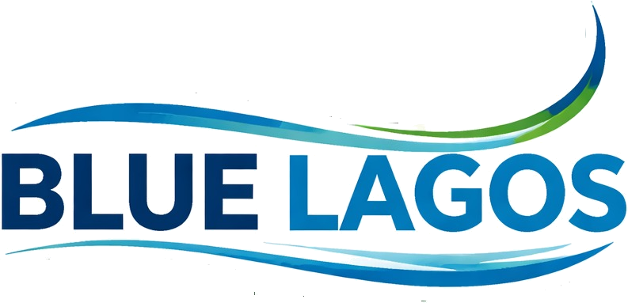
No Community is Left Behind

BLUE LAGOS COMMUNITY BASELINE REPORT
A Data-Driven Assessment of Hard-to-Reach Riverine and Coastal
Communities Across the Three Senatorial Districts of Lagos State

Prepared by Blue Lagos Initiatives
August 2026
Field survey coverage: 134 communities • 7 Local Government Areas • 3 senatorial districts

Instagram @blue.lagos | X @BlueLagos1 | YouTube Blue Lagos | www.bluelagos.org | bluelagos247@gmail.com

Table of Contents
Table of Contents 2
About Blue Lagos Sustainability Initiatives 5
Part 1 — Executive Summary 6
1.1 Purpose of This Report 6
1.2 What the Data Shows 6
1.3 Coverage at a Glance 6
1.4 Where the Communities Are 7
1.5 District Snapshot 7
1.6 Key Findings 7
1.7 How This Report Is Organized 8
1.8 Priority Recommendations 8
Part 2 — Methodology & Coverage 10
2.1 Survey Objectives 10
2.2 Sampling Frame and Community Selection 10
2.3 Data Collection Process 10
2.4 Analytical Approach 10
2.5 Coverage by Local Government Area 10
2.6 Community Geolocation 11
2.7 Indicators and Definitions 11
2.8 Scope and Next Steps 12
Part 3 — Thematic Analysis 13
3.1 Demographics 13
Household Composition 13
3.2 Civic Access: PVC and National Identification 14
3.3 Health and Emergency Response 14
3.4 Water, Sanitation, and Waste 16
3.5 Infrastructure and Connectivity 16
3.6 Education Access 17
3.7 Economy and Livelihoods 18
3.8 Governance and Past Government Presence 19
3.9 Disaster Resilience 20
3.9.1 — Purpose of This Supplement 21
3.9.2 — Elevation, Shoreline Change, and Recent Water: Regional Overview 21
3.9.3 — Shoreline Change and Recent Water Extent by LGA 22
3.9.4— Accretion Detail Along the Barrier Coastline 22
3.9.5— Elevation Distribution 23
3.9.6— Net Shoreline Change, 1984 to 2021 23
3.10 Housing and Boat Landing Infrastructure 24
3.11 Livelihoods and Food Security 24
3.12 Drinking Water Sources 25
3.13 Communication and Outreach Channels 25
3.14 Security and Dispute Resolution 25
3.15 Cross-Indicator Comparison Matrix 26
Part 4 — Civic and Voter Registration Deep Dive 26
4.1 Registration Rate by District 26
4.2 Registration Rate by Local Government Area 27
4.3 Population Reached versus Voters Registered 28
4.4 Why the PVC Barrier Matters Here Specifically 28
Part 5 — Community Need-Clusters and Spatial Patterns 29
5.1 The Four Community Clusters 29
5.2 What the Clusters Mean for Sequencing 30
5.3 Spatial Patterns 30
5.4 — Community Severity Overlaid on Elevation and LGA Boundaries 31
Part 6 — Cross-Factor Analysis: What Drives What 32
6.1 Where Deprivations Compound 32
6.2 Reading the Strongest Relationships 33
6.3 Where the Data Does Not Support a Link 33
6.4 Implication for Intervention Design 33
Part 7 — District Deep Dive 34
7.1 Lagos East 34
Epe LGA — 66 communities 34
Ibeju Lekki LGA — 9 communities 36
7.2 Lagos West 37
Amuwo Odofin LGA — 17 communities 37
Ojo LGA — 29 communities 37
Badagry LGA — 10 communities 38
7.3 Lagos Central 39
Apapa LGA — 2 communities 39
Eti Osa LGA — 1 community 39
Part 8 — Recommendations and Call to Action 40
8.1 Immediate: Zero to Six Months 40
8.2 Medium-Term: Six to Eighteen Months 40
8.3 Long-Term: Eighteen Months and Beyond 40
8.4 Recommendation-to-Cluster Reference 40
8.5 The Cost of Inaction 41
8.6 Suggested Monitoring Indicators 41
8.7 Funding and Partnership Considerations 41
Appendix 42
A.1 Glossary of Indicators 42
A.2 Cluster Membership Summary 42
A.3 Survey Instrument: Full Indicator List 42
A.4 Full Community Register 43
A.5 Community Engagement Records 43
A.6 Consolidated Indicator Reference Sheet 43
A.7 Full Community-to-Cluster Assignment 44
A.8 Media and Public Recognition 47
A.9 Communities Engagement Gallery 48

About Blue Lagos Sustainability Initiatives

Blue Lagos Sustainability Initiative (BLI) is a grassroots, impact-driven non-profit organisation working to bridge the development gap in Lagos’ underserved riverine and coastal communities. Driven by our core commitment "No Community is Left Behind" we utilise data intelligence, community engagement, advocacy, and multi-sector partnerships to connect vulnerable populations to essential services and sustainable development solutions.
Blue Lagos Initiatives works directly inside the riverine and coastal communities documented in this report, building the community relationships, field survey infrastructure, and named local contacts that make a register like this possible. The organization’s mandate is simple: no community is left behind, regardless of how difficult it is to physically reach.
That work already runs through active partnerships with government agencies and private enities.

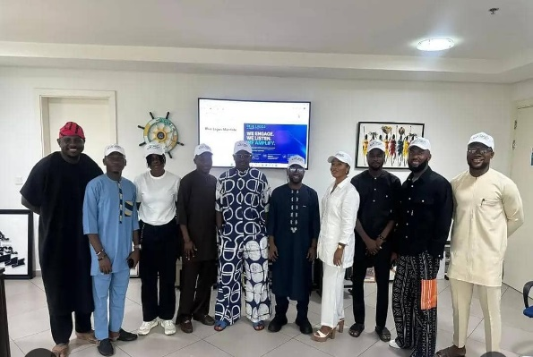
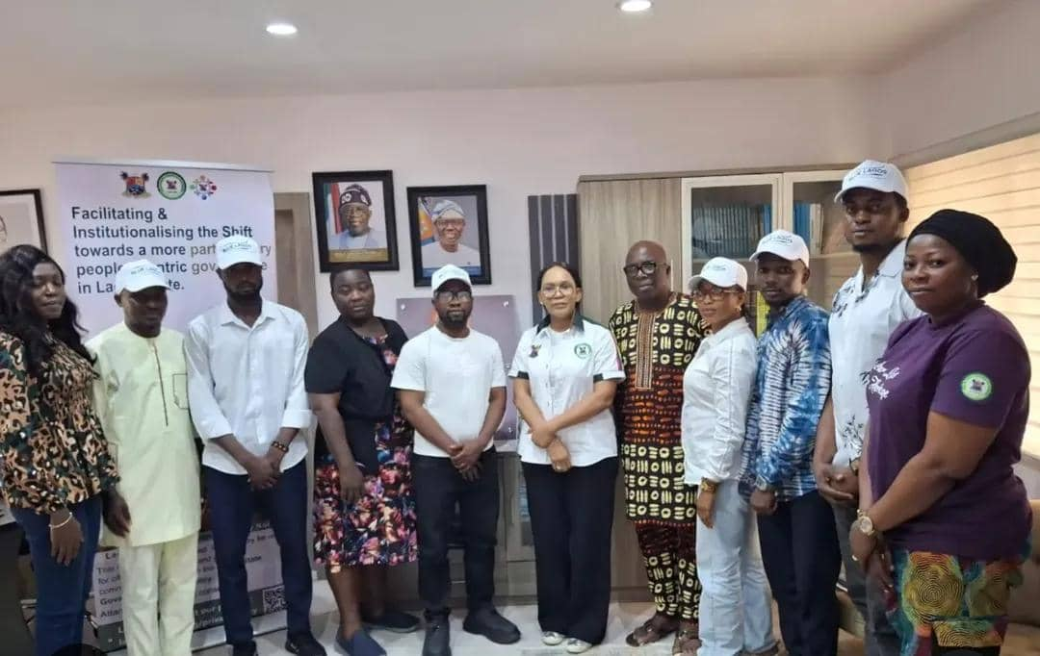
This baseline report is the evidence layer behind that ongoing collaboration: it exists so that every subsequent conversation with a government partner starts from the same verified, community-level data rather than estimates.
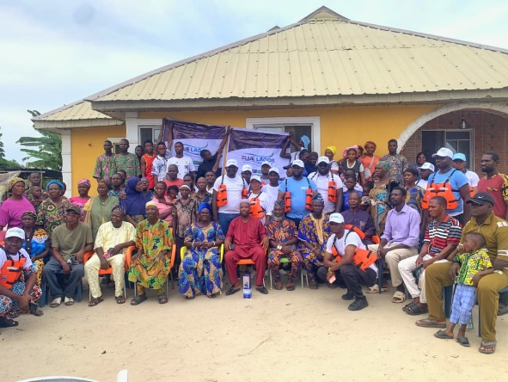
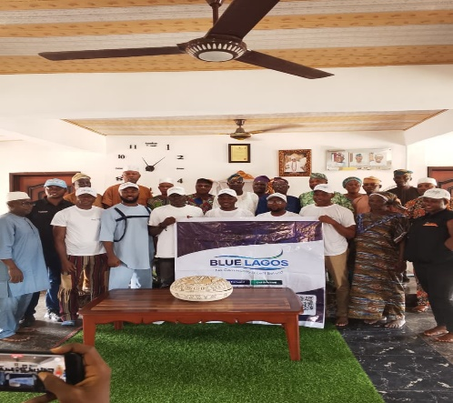
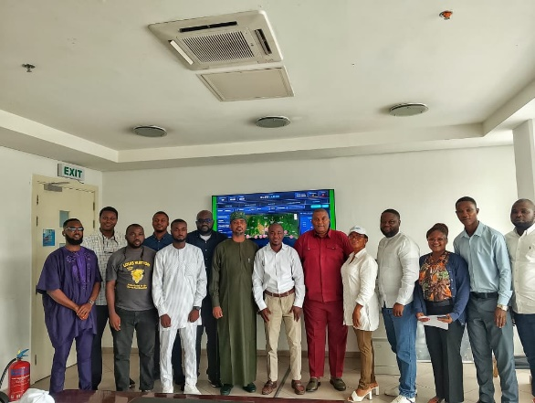









Blue Lagos Team at OPLCE Blue Lagos Team with SA On Blue economy Blue Lagos Team with LASHMA perm .secBlue Lagos Team at OPLCE
BlueLagos Team With IGA nig Ltd Community engagement at isan Epe Lga Community Enagagemnet
at Ibasa Ojo Lga

Part 1 — Executive Summary

1.1 Purpose of This Report
Between 2025 and 2026, Blue Lagos Initiatives conducted a door-to-door baseline survey of 134 riverine and coastal communities across 7 Local Government Areas, spanning all three of Lagos State's senatorial districts. The survey was designed to produce a single, reliable evidence base covering demographics, civic access, health and emergency infrastructure, water and sanitation, education, livelihoods, connectivity, and disaster resilience for communities that have historically been under-documented in state-level planning.
This report converts that field survey into a decision-ready reference. It is organized to answer three questions before resources are committed: where are the communities, what do they need, and in what order should intervention happen. Part 3 answers the first two questions theme by theme; Part 7 answers the third by ranking every community by severity; Part 8 turns both into a phased action plan.

1.2 What the Data Shows
The headline finding is not any single deprivation, but the pattern across all of them: the same communities that lack electricity also tend to lack a functioning health post, an evacuation plan, and any prior government contact. This is documented theme by theme in Part 3 and quantified directly in Part 6 — deprivation in these communities is compounding, not scattered. A community missing one form of basic infrastructure is measurably more likely to be missing several others as well.
Grouping the 134 communities by their combined need profile, rather than by geography alone, separates them into four distinct clusters detailed in Part 5: a network-cut group unique to Lagos East, a smaller institutionally under-governed group concentrated in Lagos West, a larger-population, peri-urban-adjacent group with a narrower but still significant set of gaps, and the broadest cluster of all, spanning both Lagos East and Lagos West, carrying the highest average severity score and the widest combination of unmet needs simultaneously. This distinction matters for budgeting: the intervention that closes a large peri-urban community's gaps is not the intervention the highest-severity cluster needs.

1.3 Coverage at a Glance
134  Communities Surveyed | 502,002  Estimated Population Reached | 62,494  Estimated Households | 241,053  Registered Voters | 7  Local Government Areas

91%  No prior NGO or government program | 83.6%  No formal first-aid access | 43.3%  Voice-only network, no data | 63.4%  No emergency evacuation plan

48%  Voter registration rate | 86.6%  PVC access blocked by cost or distance | 93.1%  No school beyond primary level | 81.3%  Open or open-water toilet use

1.4 Where the Communities Are
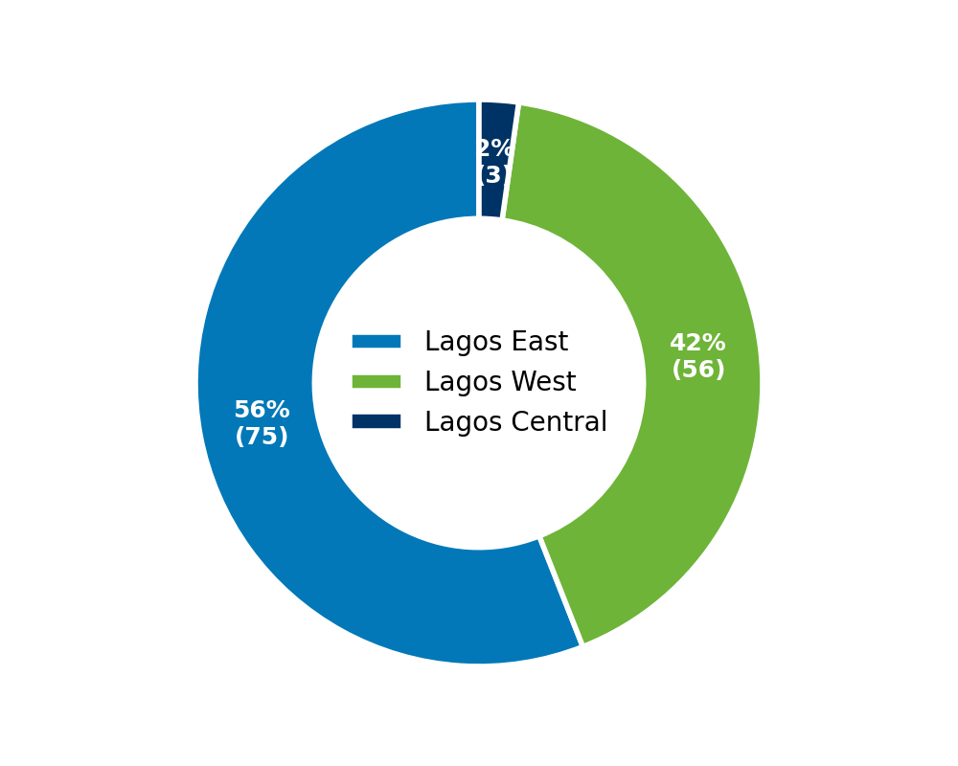 | 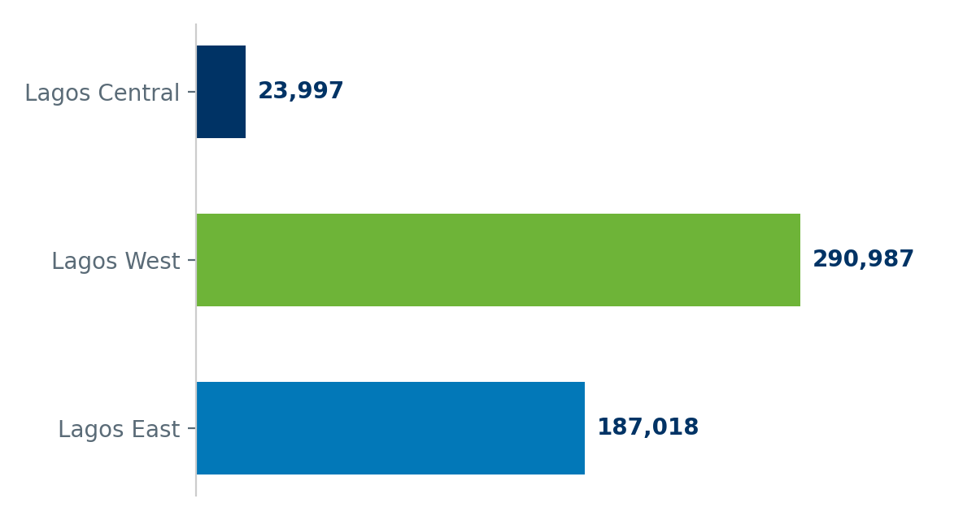

Lagos East carries the largest share of surveyed communities (75 of 134) but the smallest share of the surveyed population, a signature of small, dispersed riverine settlements rather than a few large towns. Lagos West carries the opposite pattern: fewer, larger communities holding roughly two-thirds of the surveyed population. Lagos Central's five surveyed communities are the most urbanized of the three districts and consistently score better on almost every access indicator in this report, a comparison used throughout Part 3 as the practical benchmark for what adequate coverage looks like elsewhere in the same state.

1.5 District Snapshot
Lagos East  75 communities  187,018 people | Lagos West  56 communities  290,987 people | Lagos Central  3 communities  23,997 people

1.6 Key Findings
- 91% of surveyed communities (122 of 134) have never received an NGO or government program of any kind. In Lagos East this rises to 94.7%, meaning near-total absence of any prior state contact.
- 83.6% have no formal first-aid access point, relying on traditional care or nothing at all, and 80.6% depend on an unmotorized boat, or have no means at all, to evacuate a medical emergency once it happens.
- 93.1% have no school beyond primary level physically available inside the community, and in 17.2% of communities, children already cross open water without a bridge just to reach the school that does exist.
- 81.3% practice open or open-water defecation as the primary household toilet method, a direct, quantifiable public-health exposure in communities that also report seasonal flood stagnation.
- Voter registration stands at 48% of the estimated population overall, but ranges from 40.1% in Lagos West to 61.5% in Lagos East, a gap examined in full in Part 4.
- 86.6% cite cost, distance, or both as their main barrier to obtaining a PVC, meaning the registration gap is logistical rather than attitudinal, and is addressable with a mobile registration program rather than a persuasion campaign.
- 63.4% have no designated emergency evacuation point or disaster committee, highest in Lagos West (98.2%) and Lagos Central (100%), the opposite pattern from most other indicators in this report, where Lagos East usually scores worst.
- 43.3% have voice-only mobile network with no data or 4G access, concentrated almost entirely in Lagos East (74.7% of its communities), a single-district infrastructure fix with state-wide equity implications.
- Four distinct community need-clusters emerge from the data (Part 5): a network-cut cluster unique to Lagos East; a smaller, institutionally under-governed cluster concentrated in Lagos West; a larger-population, peri-urban-adjacent cluster with narrower but still significant gaps; and the broadest cluster of the four, spanning both districts and averaging the highest severity score at 8.8 out of 13.

1.7 How This Report Is Organized
Part 2 documents how the survey was run and how the analysis in this report was built. Part 3 covers fourteen thematic areas, from civic access through disaster resilience, each compared across the three senatorial districts and then broken down to Local Government Area level, and closes with a single consolidated comparison matrix across all indicators and Local Government Areas at once. Part 4 is a dedicated deep dive into voter registration and civic reach, the one indicator in this survey that maps directly onto an existing government system. Part 5 groups all 134 communities into four data-derived need clusters and examines the limited but real relationship between geographic position and severity. Part 6 tests specific pairs of deprivations against each other to establish which problems compound and which do not. Part 7 lists every community by senatorial district and Local Government Area, ranked by severity, for direct use in prioritization. Part 8 turns all of the above into a phased, cluster-targeted action plan.

1.8 Priority Recommendations
- Deploy mobile health outreach teams to the highest-severity communities identified in Part 7, prioritizing the highest-severity cluster described in Part 5.
- Fund motorized boat ambulances for riverine communities currently dependent on unmotorized medical evacuation, starting with Epe and Ibeju-Lekki LGAs in Lagos East.
- Position this baseline, and every intervention that follows from it, as direct input to achieving Lagos State’s mega smart city goal for 2052, ensuring hard-to-reach riverine communities are built into that master plan rather than left outside it.
- Extend 4G network coverage to voice-only communities in Lagos East as a foundational step for e-governance, mobile banking, and self-service civic registration.
- Run mobile PVC and NIN registration drives directly inside communities, removing the cost and distance barrier that the large majority of respondents cite.
- Establish or activate community disaster committees and evacuation points, prioritizing Lagos West and Lagos Central where this coverage is weakest.
- Commission a targeted school-access program, covering transport, safe pedestrian bridges, or satellite classrooms, for communities with no education facility beyond primary level.

Full theme-by-theme evidence for each of these recommendations is presented in Part 3, the civic and voter registration picture is examined in Part 4, community-level need clusters in Part 5, cross-factor analysis in Part 6, and the specific communities requiring priority attention are listed by senatorial district and Local Government Area in Part 7.

Part 2 — Methodology & Coverage

2.1 Survey Objectives
This baseline survey set out to build a single, consistent evidence base for riverine and coastal communities across Lagos State that are not reliably captured in existing state or national datasets. The objectives were threefold: establish a verified community register with population and location data; document current access to civic, health, education, and infrastructure services at community level; and produce a defensible basis for prioritizing government and development investment across communities that vary enormously in size, geography, and need.

2.2 Sampling Frame and Community Selection
Coverage was built outward from Blue Lagos Initiatives' existing community relationships in Epe and Ibeju-Lekki, then extended systematically across Ojo, Amuwo Odofin, Badagry, Eti Osa, and Apapa Local Government Areas to capture riverine and coastal settlements in each of Lagos State's three senatorial districts. Communities were included where they met a working definition of a distinct settlement: a named cluster with its own recognized head or ruler, a identifiable population, and a physical location separate from neighboring clusters. This produced a register of 134 communities across 7 Local Government Areas.

2.3 Data Collection Process
Field enumerators engaged directly with each community’s recognized head or ruler, supplemented by resident interviews, using a standardized digital questionnaire covering demographics, civic access, health and emergency response, water and sanitation, housing, livelihoods, connectivity, security, and disaster history. Responses were recorded against fixed categorical options wherever possible, rather than open free text, so that findings could be aggregated and compared consistently across all communities regardless of who conducted the interview.
Each completed record includes a designated Blue Lagos community contact, giving every community a named point of continued engagement rather than a one-time data point. This is the same contact structure that will support the phased intervention plan in Part 8.

2.4 Analytical Approach
Beyond descriptive statistics, this report applies three additional layers of analysis to the raw survey responses. Part 5 groups communities into need-based clusters using unsupervised classification across thirteen deprivation indicators simultaneously, rather than ranking communities on any single measure. Part 6 tests specific pairs of indicators against each other to establish which deprivations tend to co-occur, and by how much, moving the analysis from description to explanation. Part 7 combines all thirteen indicators into a single per-community severity score, used to rank communities within each Local Government Area for prioritization purposes.

2.5 Coverage by Local Government Area
Local Government Area | Senatorial District | Communities Surveyed | Estimated Population
Epe | Lagos East | 66 | 175,273
Ojo | Lagos West | 29 | 132,881
Amuwo Odofin | Lagos West | 17 | 106,113
Badagry | Lagos West | 10 | 51,993
Ibeju Lekki | Lagos East | 9 | 11,745
Apapa | Lagos Central | 2 | 16,997
Eti Osa | Lagos Central | 1 | 7,000
TOTAL | 3 districts | 134 | 502,002

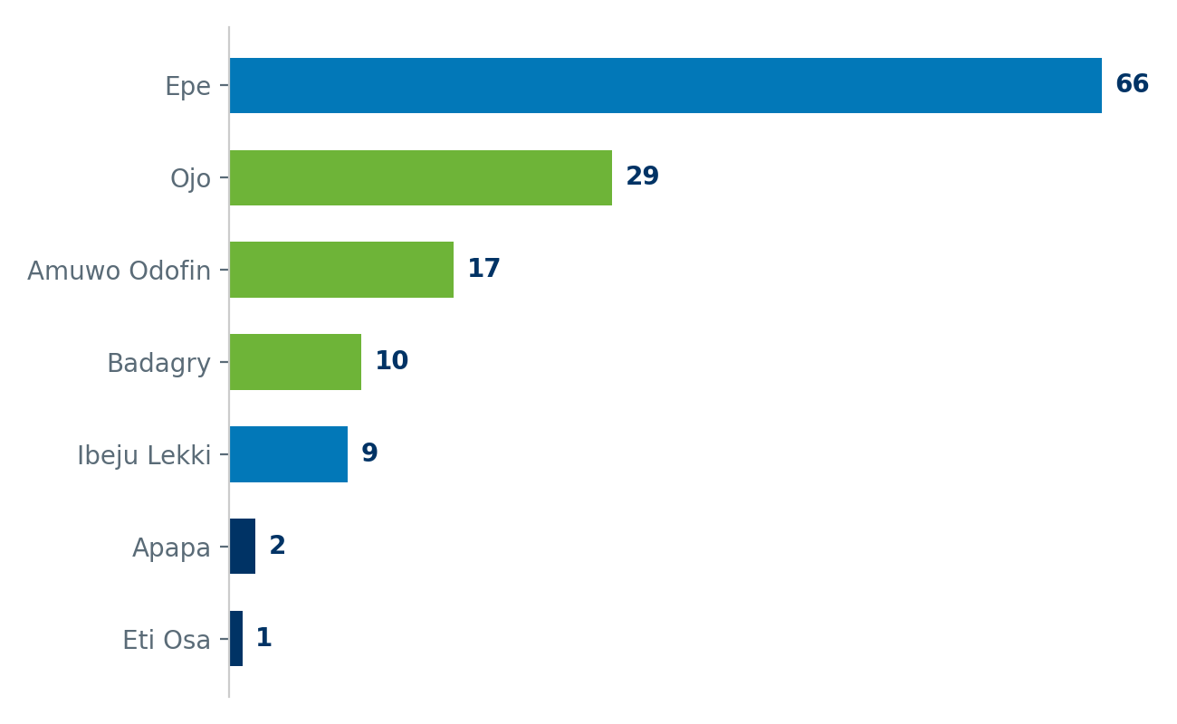

Epe LGA alone accounts for 66 communities, just under half the total register, reflecting both the density of riverine settlement in that LGA and the depth of Blue Lagos Initiatives’ existing community relationships there. Ojo and Amuwo Odofin together account for a further 46 communities in Lagos West, while Badagry, Ibeju-Lekki, Eti Osa, and Apapa complete coverage of the remaining four Local Government Areas.

2.6 Community Geolocation
Geographic coordinates have been captured for 97 of the 134 surveyed communities to date, giving a mapped sample large enough to support the spatial analysis in Part 5 while the remaining communities complete field geolocation. Coordinate coverage is strongest in Epe and weakest in the smaller LGA registers, consistent with the order in which field teams have worked through the community list.

2.7 Indicators and Definitions
Every theme in Part 3 is built from a small number of fixed-category survey questions rather than open-ended description, which is what allows this report to state, for example, that a specific percentage of communities in a specific district rely on a specific mode of medical evacuation. The full set of indicators, their category options, and the Local Government Area breakdown behind every percentage in this report accompanies this document as a structured dataset.

2.8 Scope and Next Steps
This report reflects a single baseline survey wave. It establishes what has not previously existed for these communities: a consistent, cross-comparable evidence base at community level, rather than a periodic update to an existing one. Field verification, community geolocation, and any indicator refinement identified through use of this report are expected to continue as an ongoing process alongside intervention planning rather than as a one-time exercise ahead of it. The named community contact structure described in Part 2.3 is designed specifically to support that continuation, giving each intervention a direct channel back to the community it targets rather than requiring a fresh survey wave before every subsequent engagement.

Part 3 — Thematic Analysis
This section compares every surveyed indicator across Lagos State’s three senatorial districts and, within each theme, across the seven Local Government Areas that make up this survey. District figures show the broad pattern; the Local Government Area breakdown underneath shows exactly where within that pattern the pressure is concentrated, which is the level at which intervention budgets are usually actually allocated.

3.1 Demographics
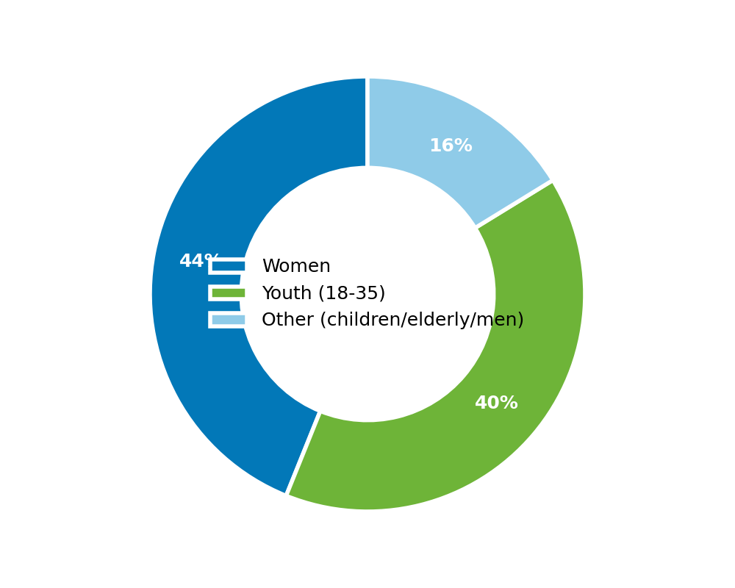

Across all 134 surveyed communities, the estimated population is 502,002, of which 220,375 are women, 200,121 are youth aged 18 to 35, and 2,615 are pregnant women requiring maternal health access.
Youth make up close to two-fifths of the surveyed population, which has two direct implications for planning. First, any livelihood or vocational intervention has a large addressable base already resident in these communities rather than needing to be attracted from outside. Second, the education gap documented later in this section, where the large majority of communities have no facility beyond primary level, is not a future problem but a present one: a significant share of this youth population passed through that exact gap already.

Household Composition
Estimated household counts per community range widely, from single-digit settlements to sizeable towns. 23.9% of communities have an estimated 1,000 or more households, while 10.4% have fewer than 50, a spread that confirms this survey covers both compact riverine hamlets and substantial settlements within the same register.
Estimated Households per Community | Share of Communities
Fewer than 50 households | 10.4%
50 to 199 households | 41.8%
200 to 499 households | 12.7%
500 to 999 households | 11.2%
More than 1,000 households | 23.9%

3.2 Civic Access: PVC and National Identification
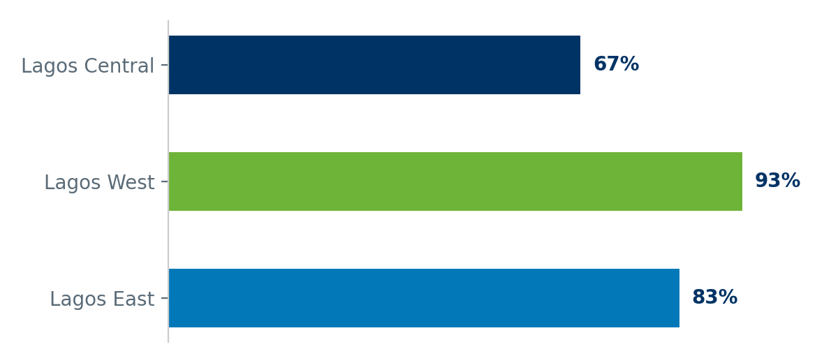

Metric | Lagos East | Lagos West | Lagos Central
PVC access blocked by cost, distance, or both | 82.7% | 92.9% | 66.7%

By Local Government Area
LGA | Epe | Ibeju Lekki | Ojo | Amuwo Odofin | Badagry | Eti Osa | Apapa
% of communities | 83.3% | 77.8% | 89.7% | 100% | 90% | 100% | 50%

86.6% of communities cite cost of travel, the absence of a nearby registration center, or both, as their main barrier to obtaining a Permanent Voter's Card. This is highest in Lagos West at 92.9%.
Because the barrier is logistical rather than attitudinal, a mobile registration unit visiting communities directly on a fixed schedule would remove it at the source, rather than requiring residents to self-fund travel to a fixed center. Part 4 examines what this barrier means in terms of actual registered voters lost.

3.3 Health and Emergency Response
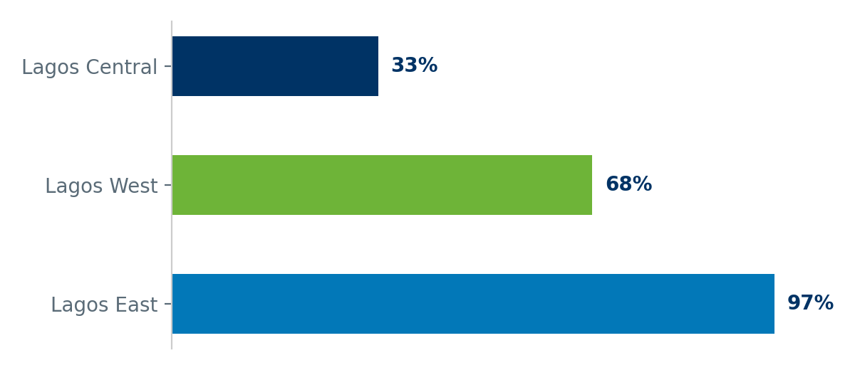

Metric | Lagos East | Lagos West | Lagos Central
No formal first-aid access point in community (traditional or none) | 97.3% | 67.9% | 33.3%

By Local Government Area
LGA | Epe | Ibeju Lekki | Ojo | Amuwo Odofin | Badagry | Eti Osa | Apapa
% of communities | 98.5% | 88.9% | 69% | 82.4% | 40% | 0% | 50%

83.6% of communities have no formal first-aid access point, relying instead on traditional care or nothing at all. This is most acute in Lagos East, at 97.3%, where formal health infrastructure is almost entirely absent from the communities surveyed, and in Epe LGA specifically, where the figure exceeds the district average.

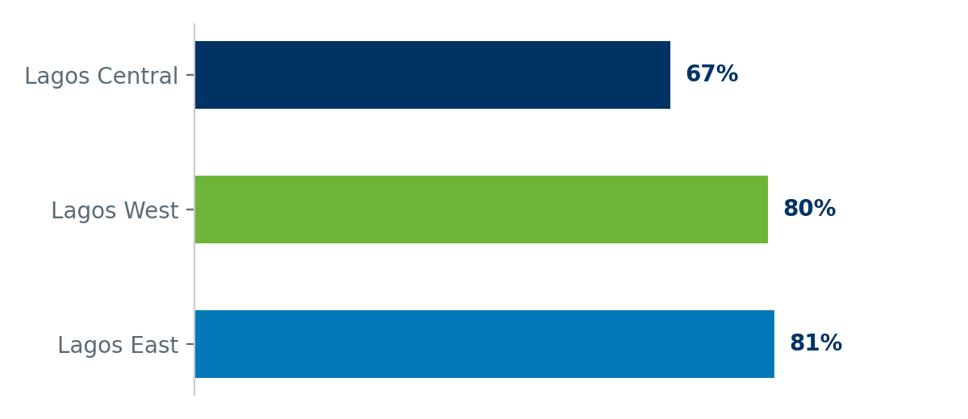

Metric | Lagos East | Lagos West | Lagos Central
Rely on unmotorized boat, or no means, for medical evacuation | 81.3% | 80.4% | 66.7%

By Local Government Area
LGA | Epe | Ibeju Lekki | Ojo | Amuwo Odofin | Badagry | Eti Osa | Apapa
% of communities | 86.4% | 44.4% | 86.2% | 64.7% | 90% | 0% | 100%

80.6% of communities depend on an unmotorized boat, or have no means at all, to evacuate a medical emergency, a gap that is consistent across all three districts rather than concentrated in one.
A consistent cross-district gap like this one is better addressed as a state-wide riverine ambulance program than as a district-by-district allocation, since no single district has a materially better starting position than the others.

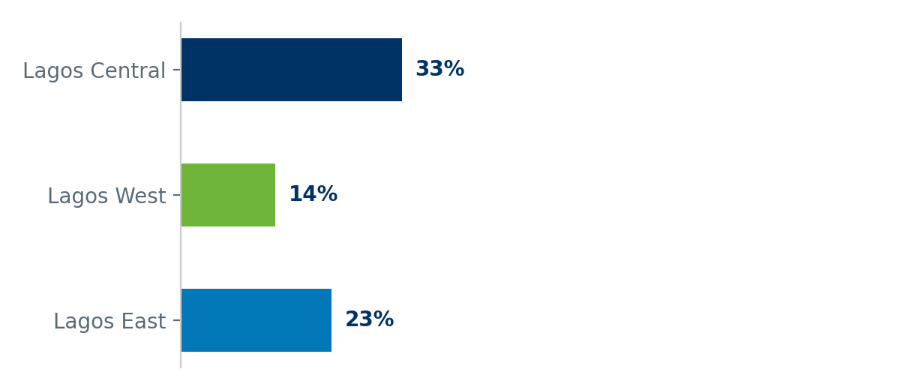

Metric | Lagos East | Lagos West | Lagos Central
No immunisation team visit in last 12 months | 22.7% | 14.3% | 33.3%

By Local Government Area
LGA | Epe | Ibeju Lekki | Ojo | Amuwo Odofin | Badagry | Eti Osa | Apapa
% of communities | 21.2% | 33.3% | 3.4% | 17.6% | 40% | 0% | 50%

19.4% of communities report no immunisation or vaccination team visit in the past 12 months, and 40.3% of residents believe not all eligible children in their community are currently reached by routine immunisation services.

3.4 Water, Sanitation, and Waste
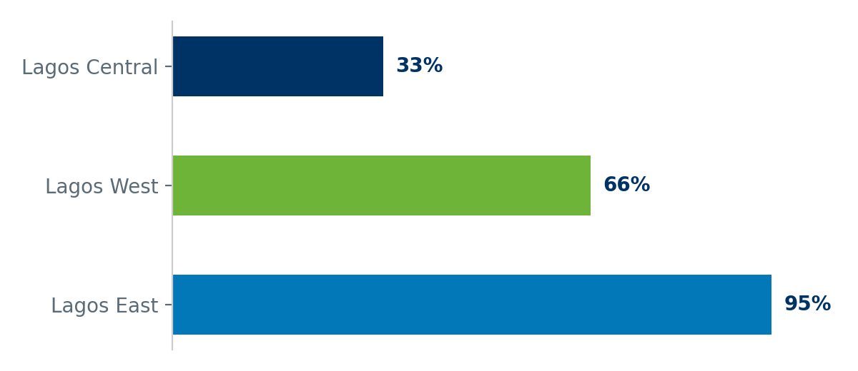

Metric | Lagos East | Lagos West | Lagos Central
Open-defecation or open-water toilet practice (no shared or flush facility) | 94.7% | 66.1% | 33.3%

By Local Government Area
LGA | Epe | Ibeju Lekki | Ojo | Amuwo Odofin | Badagry | Eti Osa | Apapa
% of communities | 95.5% | 88.9% | 75.9% | 35.3% | 90% | 0% | 50%

81.3% of communities practice open or open-water defecation as the primary household toilet method, rising to 94.7% in Lagos East. This is both a public health risk in its own right and a direct contributor to waterborne disease in communities that also report multi-day flood stagnation during the rainy season.

3.5 Infrastructure and Connectivity
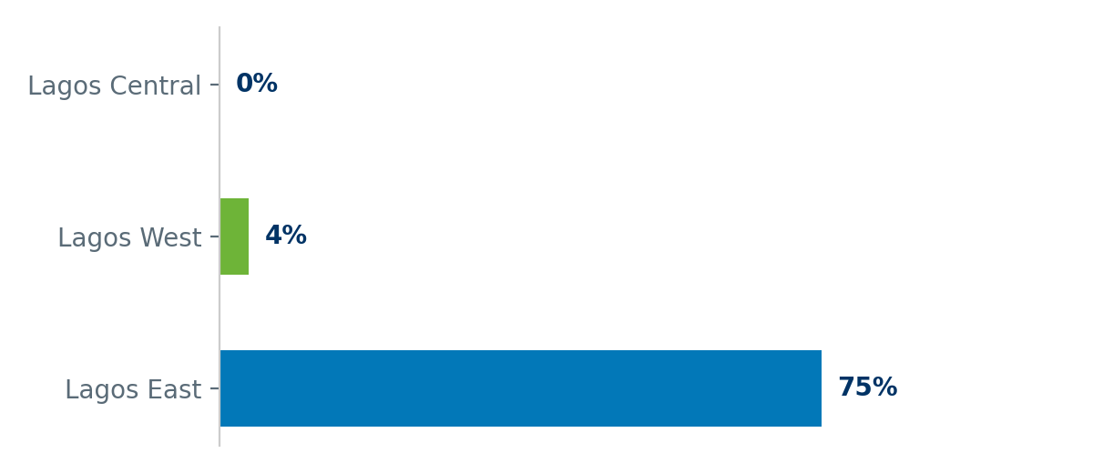

Metric | Lagos East | Lagos West | Lagos Central
Communities with voice-only network (no data or 4G) | 74.7% | 3.6% | 0%

By Local Government Area
LGA | Epe | Ibeju Lekki | Ojo | Amuwo Odofin | Badagry | Eti Osa | Apapa
% of communities | 77.3% | 55.6% | 0% | 0% | 20% | 0% | 0%

43.3% of communities have voice-only mobile network coverage with no data or 4G access. This is almost entirely a Lagos East problem, at 74.7% of its communities, compared to near-zero in Lagos West and Lagos Central, and it blocks residents from mobile banking, e-governance services, and remote PVC and NIN self-service.
Because this gap is concentrated in one district rather than spread evenly, it is one of the few indicators in this report where a single infrastructure investment, a targeted 4G rollout in Epe and Ibeju-Lekki, would close the majority of the state-wide gap in one move.

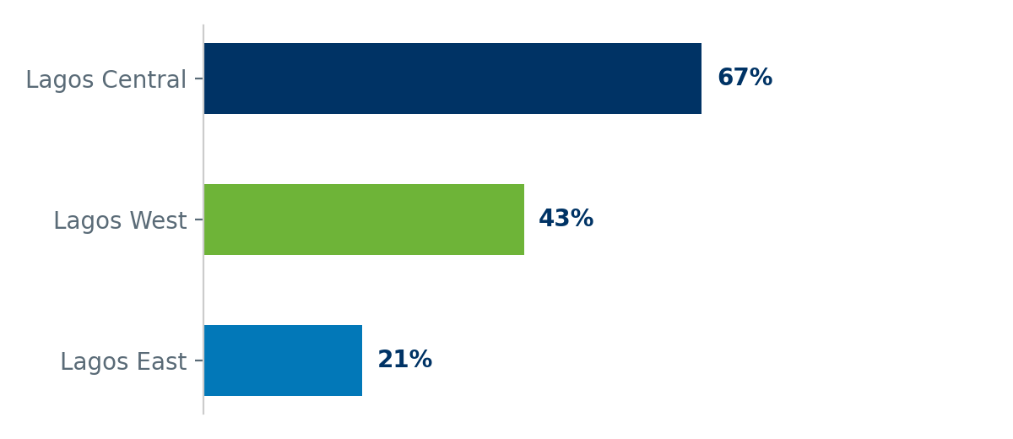

Metric | Lagos East | Lagos West | Lagos Central
No electricity source (generator, grid, or solar) for lighting | 21.3% | 42.9% | 66.7%

By Local Government Area
LGA | Epe | Ibeju Lekki | Ojo | Amuwo Odofin | Badagry | Eti Osa | Apapa
% of communities | 21.2% | 22.2% | 55.2% | 23.5% | 40% | 100% | 50%

31.3% of communities have no electricity source at all for lighting at night, highest in Lagos West at 42.9%.

3.6 Education Access
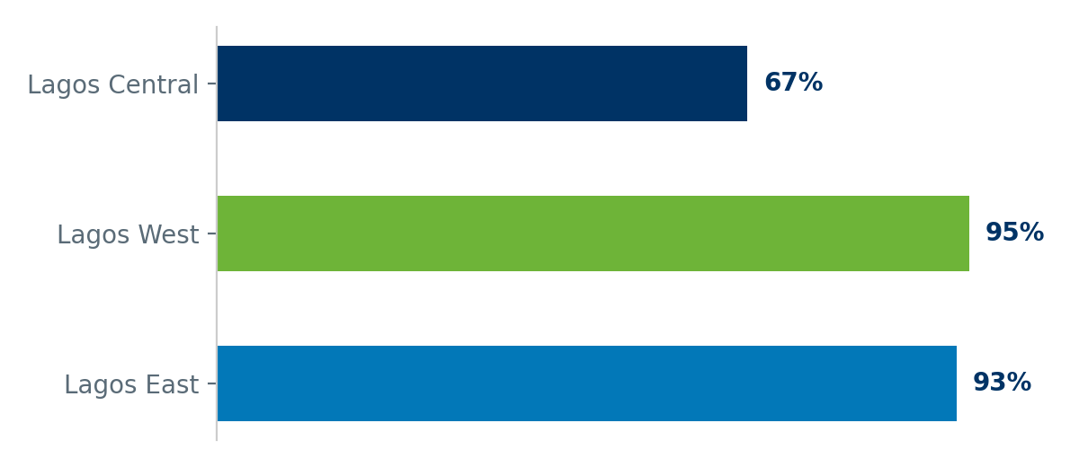

Metric | Lagos East | Lagos West | Lagos Central
No education facility beyond primary level (or none at all) inside community | 93% | 94.6% | 66.7%

By Local Government Area
LGA | Epe | Ibeju Lekki | Ojo | Amuwo Odofin | Badagry | Eti Osa | Apapa
% of communities | 91.7% | 100% | 100% | 82.4% | 100% | 0% | 100%

93.1% of communities have no education facility beyond primary level physically present, meaning secondary-age students must travel out of the community or stop schooling altogether.

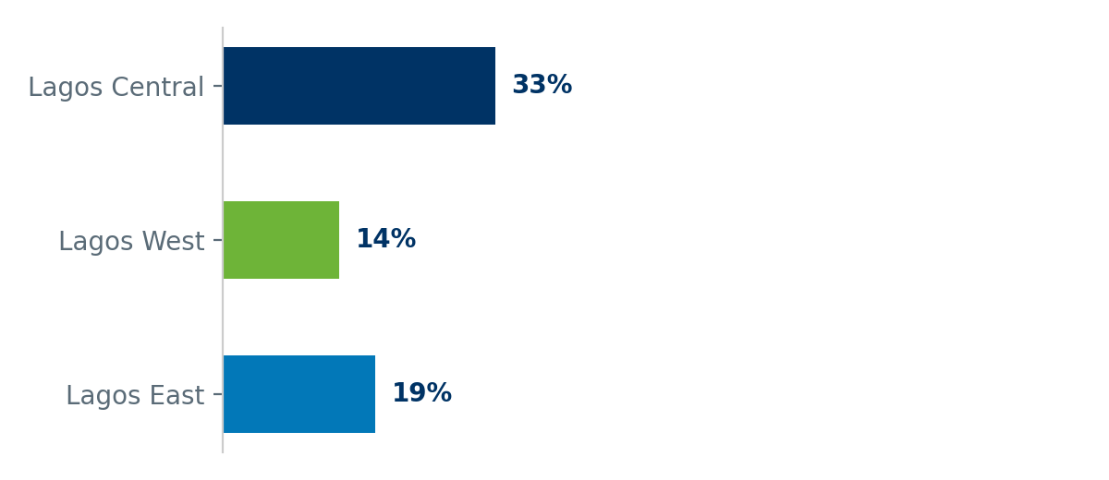

Metric | Lagos East | Lagos West | Lagos Central
Children cross open water without a bridge to reach school | 18.7% | 14.3% | 33.3%

By Local Government Area
LGA | Epe | Ibeju Lekki | Ojo | Amuwo Odofin | Badagry | Eti Osa | Apapa
% of communities | 18.2% | 22.2% | 6.9% | 11.8% | 40% | 0% | 50%

In 17.2% of communities, children are forced to cross open water or major transit routes without a pedestrian bridge to reach the nearest school, a direct safety hazard layered on top of the access gap above.
Read together, these two indicators describe the same underlying problem from two angles: not only is school access physically distant for most of these communities, the journey itself carries a documented safety risk for the children making it daily.

3.7 Economy and Livelihoods
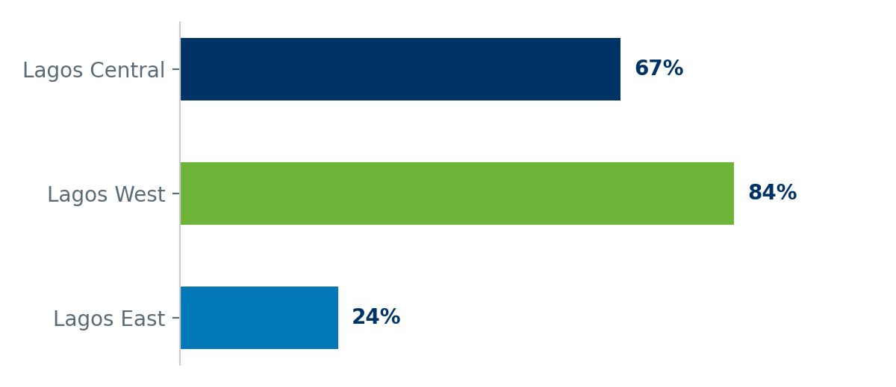

Metric | Lagos East | Lagos West | Lagos Central
No active cooperative or thrift society (Esusu or Ajo) | 24% | 83.9% | 66.7%

By Local Government Area
LGA | Epe | Ibeju Lekki | Ojo | Amuwo Odofin | Badagry | Eti Osa | Apapa
% of communities | 24.2% | 22.2% | 82.8% | 100% | 60% | 100% | 50%

50% of communities have no active cooperative or thrift society, commonly known locally as Esusu or Ajo, a traditional and low-cost channel for economic resilience and micro-lending. This gap is most pronounced in Lagos West at 83.9%.
Because these structures are already culturally established rather than needing to be introduced from outside, restarting or formalizing dormant cooperatives is typically faster and cheaper than building new financial-inclusion infrastructure from scratch.

3.8 Governance and Past Government Presence
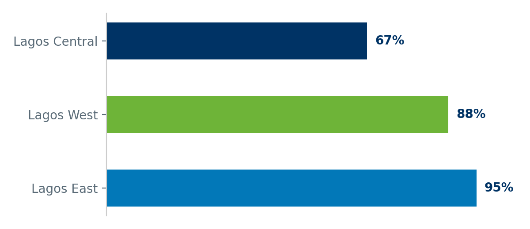

Metric | Lagos East | Lagos West | Lagos Central
Communities with no prior NGO or government program | 94.7% | 87.5% | 66.7%

By Local Government Area
LGA | Epe | Ibeju Lekki | Ojo | Amuwo Odofin | Badagry | Eti Osa | Apapa
% of communities | 95.5% | 88.9% | 96.6% | 88.2% | 60% | 100% | 50%

91% of communities report having never received an NGO or government program of any kind. Lagos Central is the exception at 66.7%, reflecting its more urbanized Local Government Areas; Lagos East, at 94.7%, is almost entirely unreached.

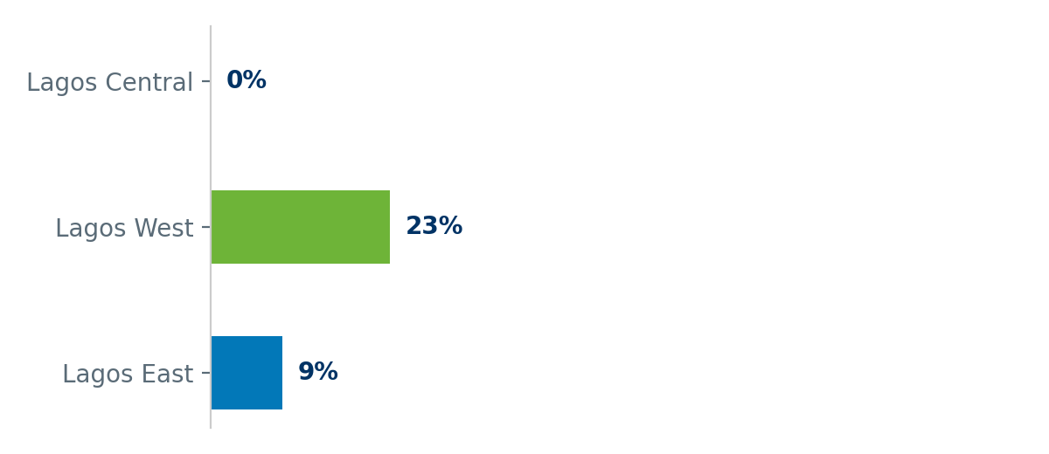

Metric | Lagos East | Lagos West | Lagos Central
Past government project abandoned in community | 9.3% | 23.2% | 0%

By Local Government Area
LGA | Epe | Ibeju Lekki | Ojo | Amuwo Odofin | Badagry | Eti Osa | Apapa
% of communities | 7.6% | 22.2% | 24.1% | 5.9% | 50% | 0% | 0%

Where a past government project did reach a community, 14.9% describe it as abandoned rather than functional, a trust and follow-through issue that any new intervention should be designed to visibly avoid repeating, for instance through a named ongoing community contact of the kind described in Part 2.

3.9 Disaster Resilience
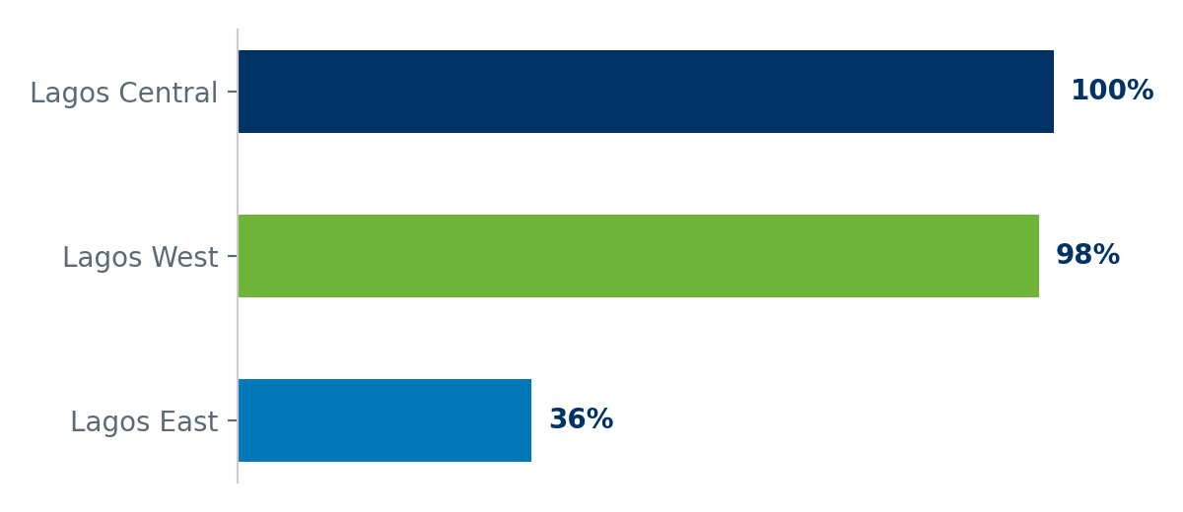

Metric | Lagos East | Lagos West | Lagos Central
Communities with no emergency evacuation point or committee | 36% | 98.2% | 100%

By Local Government Area
LGA | Epe | Ibeju Lekki | Ojo | Amuwo Odofin | Badagry | Eti Osa | Apapa
% of communities | 33.3% | 55.6% | 100% | 94.1% | 100% | 100% | 100%

63.4% of communities have no designated emergency evacuation point or disaster committee. This is near-universal in Lagos West (98.2%) and Lagos Central (100%), and comparatively better, though still a majority gap, in Lagos East.

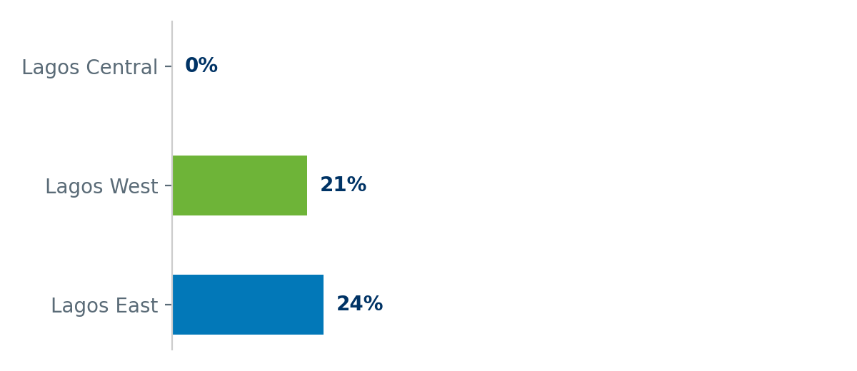

Metric | Lagos East | Lagos West | Lagos Central
Communities that lost land or houses to erosion (minor or severe) | 24% | 21.4% | 0%

By Local Government Area
LGA | Epe | Ibeju Lekki | Ojo | Amuwo Odofin | Badagry | Eti Osa | Apapa
% of communities | 22.7% | 33.3% | 6.9% | 35.3% | 40% | 0% | 0%

22.4% of communities report having lost living space or houses to riverbank erosion or water encroachment in the last five years, split between minor and severe cases across all three districts.
Part 6 quantifies exactly how much more likely an erosion-affected community is to also lack an evacuation plan, the combination that turns a slow-moving land loss problem into an acute life-safety one.

3.9.1 — Purpose of This Supplement
This supplement extends the erosion and disaster-resilience findings in Part 3.9 and the spatial pattern analysis in Part 5.3 of the Blue Lagos Community Baseline Report with satellite-derived evidence ground elevation, thirty seven years of shoreline change, and post-2018 water extent change, mapped directly against the seven focus Local Government Areas and the surveyed communities within them.
All layers are built from open satellite datasets in Google Earth Engine: elevation from the MERIT Digital Elevation Model, historical shoreline change from the JRC Global Surface Water dataset (1984 to 2021), and recent water extent from Sentinel-2 imagery. Community locations and severity scores are drawn directly from this survey’s own dataset.

3.9.2 — Elevation, Shoreline Change, and Recent Water: Regional Overview
This view combines all three satellite layers across the wider Lagos coastal belt. Ground elevation is shown in red (under 2 meters, critical), orange (2 to 5 meters, vulnerable), and green (above 5 meters, safer). The concentrated red zone on the eastern side of the map, spanning Epe and Ibeju-Lekki, is the same area this report’s severity ranking (Part 7) already identifies as carrying the highest concentration of critical severity communities the satellite data and the field survey are pointing at the same geography independently.
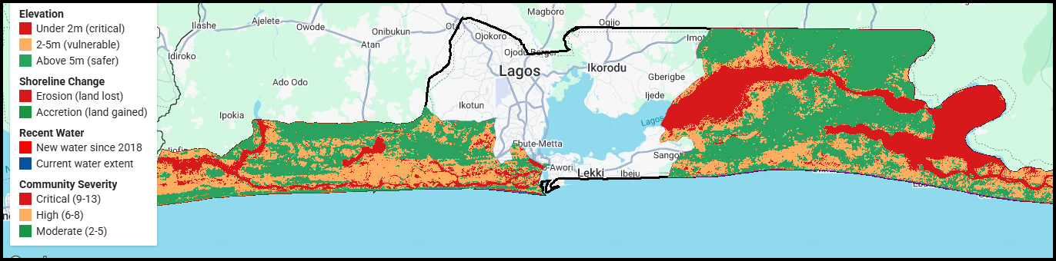
Figure 1. Elevation, shoreline change, and recent water extent across the Lagos coastal belt, focus LGAs outlined in black.

3.9.3 — Shoreline Change and Recent Water Extent by LGA
Isolating shoreline change and post-2018 water extent from the elevation layer makes the erosion pattern easier to read on its own. Red marks stretches of coastline that have retreated since 1984; the blue mass over the Lagos Lagoon and Lekki Lagoon shows current water extent. The erosion signal is visibly concentrated along the immediate coastline and lagoon edges of Epe and Ibeju-Lekki, consistent with the communities already flagged as erosion-affected in Part 3.9 of the main report.
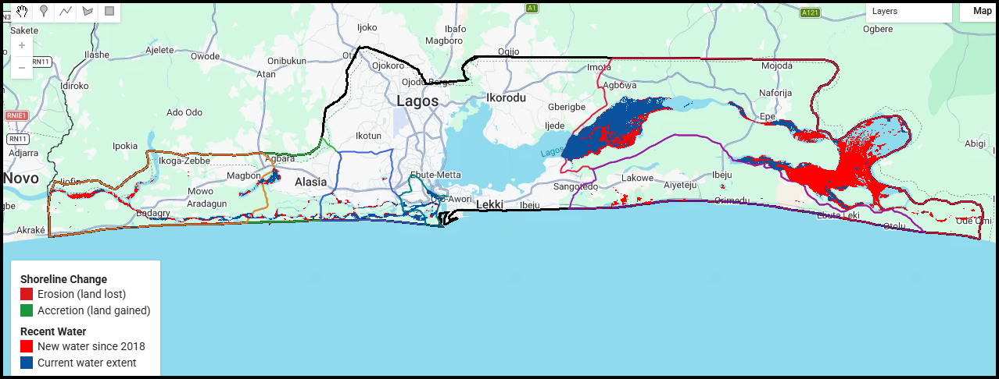
Figure 3. Shoreline retreat and current water extent, focus LGAs outlined in color.

3.9.4— Accretion Detail Along the Barrier Coastline
A closer view of the same shoreline-change layer shows extensive green accretion, land gain, along the outer barrier coastline running from Badagry through to Lekki. This is an important counterpoint to Map 3: land loss is not uniform across the coast. Net land gain along this stretch does not mean these communities are safe from other risks documented in this report (flooding, poor drainage, lack of evacuation infrastructure); it means the erosion risk specifically is concentrated elsewhere, chiefly in the lagoon-facing communities of Epe and Ibeju-Lekki shown in Maps 1 through 3.
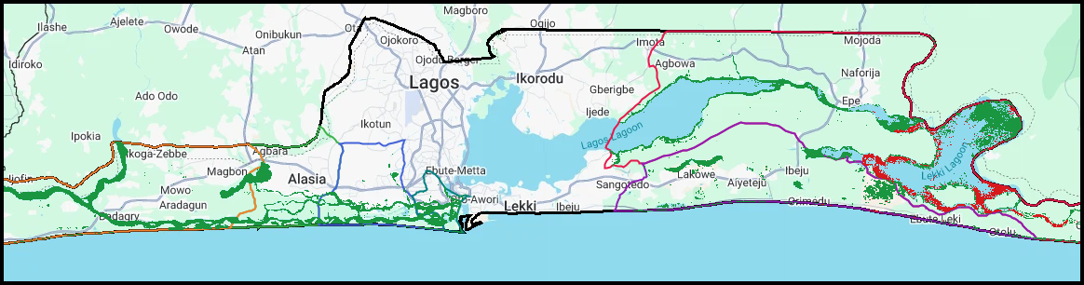
Figure 4. Accretion (land gain) pattern along the outer barrier coastline.

3.9.5— Elevation Distribution
The 2-meter and 5-meter thresholds used throughout this supplement follow conventional coastal flood-risk bands rather than a statistical break specific to this dataset. It is also worth noting that satellite elevation data can overstate ground height in areas with dense mangrove or wetland vegetation, like Lagos's riverine communities, because the satellite sometimes reads the top of the plant cover rather than the ground beneath it. This is one reason the map's 'vulnerable' and 'safer' bands should be read as broad risk categories rather than precise elevation measurements for any single community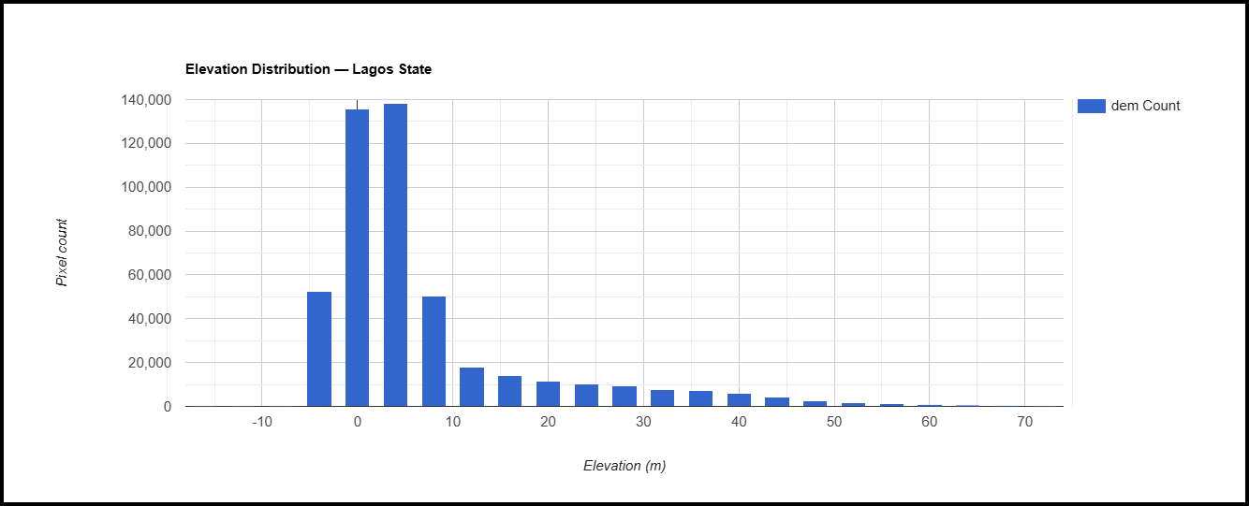
Chart 1. Elevation distribution across Lagos State (MERIT DEM).

3.9.6— Net Shoreline Change, 1984 to 2021
State-wide, accretion outpaces erosion by roughly four to one over this 37-year period: an estimated 230 square kilometers of land gained against 60 square kilometers lost. Read on its own, this looks reassuring. Read alongside Maps 1 through 3, it is not the state-wide net figure is driven by accretion along the outer barrier coastline (Map 4), while the erosion losses are concentrated almost entirely in the lagoon-facing riverine communities this report is about. A positive state-wide balance can, and here does, coexist with severe, localized erosion in exactly the communities with the least capacity to absorb it the same communities flagged as having no evacuation plan in Part 3.9.
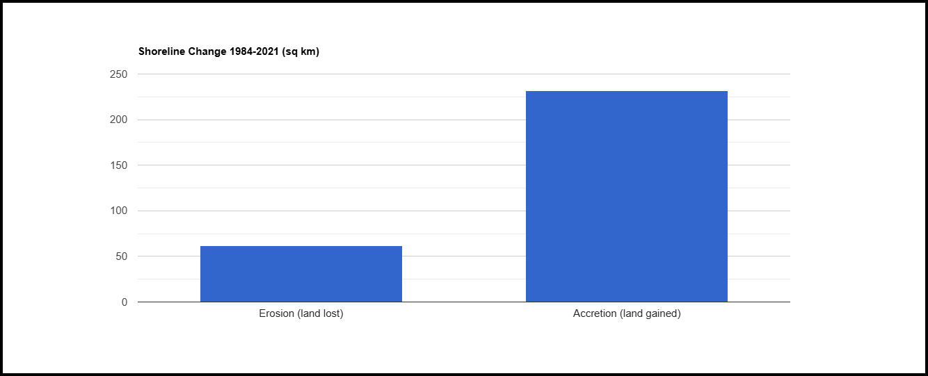
Chart 2. Net shoreline change in square kilometers, Lagos State, 1984-2021 (JRC Global Surface Water).

3.10 Housing and Boat Landing Infrastructure
Housing construction is split almost evenly between wood (56.7%) and concrete (41.8%) as the dominant wall material, with wood constructions concentrated in the more riverine, lower-income community clusters described in Part 5. This matters directly for disaster planning: wood-walled housing is measurably more vulnerable to the erosion and flood risks documented in Part 3.9, and the two indicators should be read together rather than separately when prioritizing structural resilience investment.
Category | Lagos East | Lagos West | Lagos Central
Wood | 78.7% | 28.6% | 33.3%
Concrete | 18.7% | 71.4% | 66.7%
Thatch | 2.7% | 0% | 0%

Boat landing infrastructure, the point where most riverine communities' medical evacuation, market access, and daily transport all converge, is an unimproved mudbank in 64.9% of communities, with concrete or wooden improvements each accounting for roughly a fifth of the remainder. Given how heavily Part 3.3 shows these communities depend on boat transport for medical emergencies, the physical condition of the landing point itself is a safety-relevant infrastructure gap in its own right, not just a convenience issue.
Category | Lagos East | Lagos West | Lagos Central
Mudbank (unimproved) | 73.3% | 51.8% | 100%
Wooden | 22.7% | 14.3% | 0%
Concrete | 4% | 33.9% | 0%

3.11 Livelihoods and Food Security
Fishing is the dominant primary occupation across the survey at 64.9%, followed by farming at 17.2% and trading at 12.7%. This livelihood profile is consistent with the market-access barrier already documented in Part 3.7: a community that is overwhelmingly dependent on fishing and farming, but structurally unable to get its catch or harvest to market at a fair price, is economically constrained by infrastructure rather than by the underlying livelihood activity itself.
Category | Lagos East | Lagos West | Lagos Central
Fishing | 89.3% | 30.4% | 100%
Farming | 9.3% | 28.6% | 0%
Trading | 0% | 30.4% | 0%

During the off-season, severe weather, or flooding, 75.4% of communities rely on stored reserves to secure daily food, while 17.2% report skipping meals outright. The second figure is a direct, measurable food-insecurity indicator that sits underneath the broader livelihood picture and should be treated as its own line item in any welfare-focused intervention, separate from the longer-term market-access recommendations in Part 8.
Category | Lagos East | Lagos West | Lagos Central
Stored reserves | 77.3% | 71.4% | 100%
Skipping meals | 9.3% | 28.6% | 0%
Relief support | 9.3% | 0% | 0%
Community sharing | 4% | 0% | 0%

3.12 Drinking Water Sources
A well is the primary everyday drinking water source for 61.9% of communities, with borehole water accounting for a further 28.4% and river water, the least protected source, still serving 6.7% of communities directly. Read alongside the sanitation findings in Part 3.4, where open and open-water toilet use is the norm rather than the exception, the water and sanitation gap in this survey is not two separate problems but one shared exposure pathway, and should be budgeted as a single combined water, sanitation, and hygiene program rather than as separate water and sanitation line items.
Category | Lagos East | Lagos West | Lagos Central
Well | 81.3% | 37.5% | 33.3%
Borehole | 6.7% | 57.1% | 33.3%
River | 10.7% | 1.8% | 0%

3.13 Communication and Outreach Channels
Community leaders combined with social media is the dominant information channel, cited as one of the top two ways residents receive information in 54.5% of communities, ahead of leaders combined with religious channels at 19.4%. This has a direct, practical implication for every outreach-dependent recommendation in this report: a government mobile registration drive, health outreach visit, or disaster-preparedness campaign will reach these communities fastest and most credibly by working through recognized community leaders first, with social media as the secondary, supporting channel, rather than through mass broadcast media alone.

Primary Channel Combination | Share of Communities
Community leaders and Social media | 54.5%
Community leaders and Religious leaders | 19.4%
Social media | 8.2%
Community leaders | 6.7%
Community leaders and Radio | 3%
Community leaders and NGO meetings | 3%

3.14 Security and Dispute Resolution
Where a security incident or land dispute arises, 86.6% of communities go first to a traditional authority rather than the police, who are cited as the primary channel in only 12.7% of communities. This is not necessarily a gap to be closed by redirecting communities toward formal policing; it reflects an existing, functioning local governance structure. The practical implication for government engagement is the same one that runs through this report: the community head or ruler is the entry point that already carries legitimacy here, and any new program, from PVC registration to health outreach, should be introduced through that structure rather than around it.
Category | Lagos East | Lagos West | Lagos Central
traditional | 96% | 75% | 66.7%
police | 4% | 23.2% | 33.3%

3.15 Cross-Indicator Comparison Matrix
The table below consolidates all fifteen deprivation indicators used throughout Part 3 into a single view, one row per indicator, one column per Local Government Area. Darker shading marks a higher percentage of affected communities. This is the single reference table for identifying which Local Government Area carries the heaviest concentration of a specific problem, and is the working table behind the Local Government Area-level targeting decisions recommended in Part 8.

Indicator | Epe | Ibeju Lekki | Ojo | Amuwo Odofin | Badagry | Eti Osa | Apapa
No prior program | 95.5% | 88.9% | 96.6% | 88.2% | 60% | 100% | 50%
Voice-only network | 77.3% | 55.6% | 0% | 0% | 20% | 0% | 0%
No evacuation plan | 33.3% | 55.6% | 100% | 94.1% | 100% | 100% | 100%
Erosion-affected | 22.7% | 33.3% | 6.9% | 35.3% | 40% | 0% | 0%
Unsafe school route | 18.2% | 22.2% | 6.9% | 11.8% | 40% | 0% | 50%
No cooperative | 24.2% | 22.2% | 82.8% | 100% | 60% | 100% | 50%
No immunisation visit | 21.2% | 33.3% | 3.4% | 17.6% | 40% | 0% | 50%
Immunisation gap belief | 30.3% | 33.3% | 65.5% | 23.5% | 70% | 0% | 50%
No electricity | 21.2% | 22.2% | 55.2% | 23.5% | 40% | 100% | 50%
Open toilet use | 95.5% | 88.9% | 75.9% | 35.3% | 90% | 0% | 50%
No formal health access | 98.5% | 88.9% | 69% | 82.4% | 40% | 0% | 50%
Unmotorized evacuation | 86.4% | 44.4% | 86.2% | 64.7% | 90% | 0% | 100%
No school beyond primary | 91.7% | 100% | 100% | 82.4% | 100% | 0% | 100%
Past project abandoned | 7.6% | 22.2% | 24.1% | 5.9% | 50% | 0% | 0%
PVC barrier | 83.3% | 77.8% | 89.7% | 100% | 90% | 100% | 50%

Reading down any single column identifies that Local Government Area’s full deprivation profile at a glance; reading across any single row identifies which Local Government Areas are driving a district-level average up or down. Epe carries the deepest and widest shading of the seven, consistent with its dominance of the highest-severity clusters identified in Part 5.

Part 4 — Civic and Voter Registration Deep Dive
Registered voters are the one indicator in this survey that already exists in a government system before Blue Lagos ever reached these communities, which makes the gap between estimated population and registered voters a direct, auditable measure of civic reach. Across all 134 communities, 241,053 residents are registered voters against an estimated population of 502,002, a registration rate of 48%.

4.1 Registration Rate by District
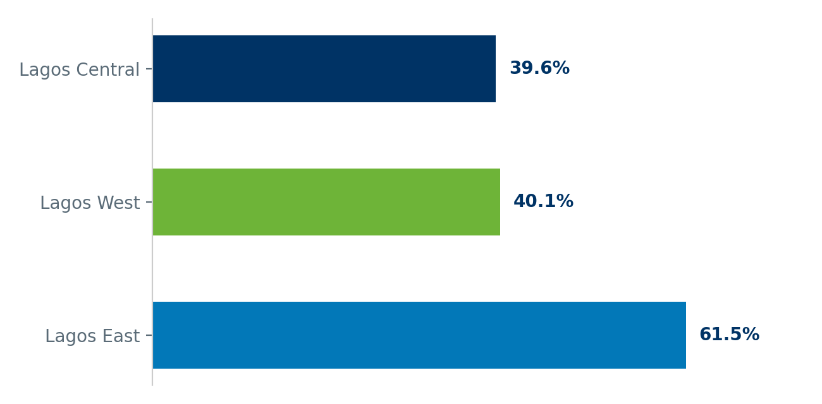

District | Population | Registered Voters | Registration Rate
Lagos Central | 23,997 | 9,499 | 39.6%
Lagos East | 187,018 | 115,004 | 61.5%
Lagos West | 290,987 | 116,550 | 40.1%

Lagos West carries two-thirds of the total surveyed population but the lowest registration rate of the three districts, at 40.1%. Lagos East, despite scoring worse than Lagos West on almost every other indicator in Part 3, has the highest registration rate at 61.5%. This inversion matters for planning: the district with the largest unregistered population in absolute terms, and therefore the largest opportunity for a registration drive, is Lagos West, not the district that looks most deprived on service-access grounds alone.

4.2 Registration Rate by Local Government Area
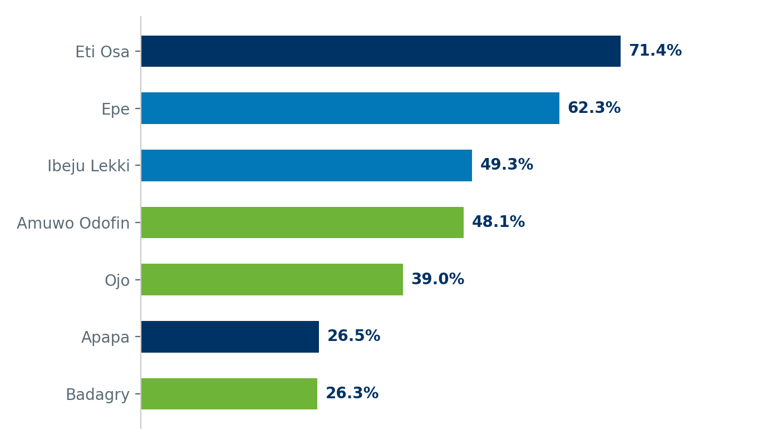

LGA | District | Population | Registered Voters | Registration Rate
Eti Osa | Lagos Central | 7,000 | 5,000 | 71.4%
Epe | Lagos East | 175,273 | 109,212 | 62.3%
Ibeju Lekki | Lagos East | 11,745 | 5,792 | 49.3%
Amuwo Odofin | Lagos West | 106,113 | 51,026 | 48.1%
Ojo | Lagos West | 132,881 | 51,850 | 39%
Apapa | Lagos Central | 16,997 | 4,499 | 26.5%
Badagry | Lagos West | 51,993 | 13,674 | 26.3%

The Local Government Area breakdown sharpens the district picture considerably. Registration rates vary by a wide margin even within the same district, which means a district-level registration target would miss the specific Local Government Areas that need it most. Any mobile registration deployment should be planned at Local Government Area level, using this table directly, rather than at district level.

4.3 Population Reached versus Voters Registered
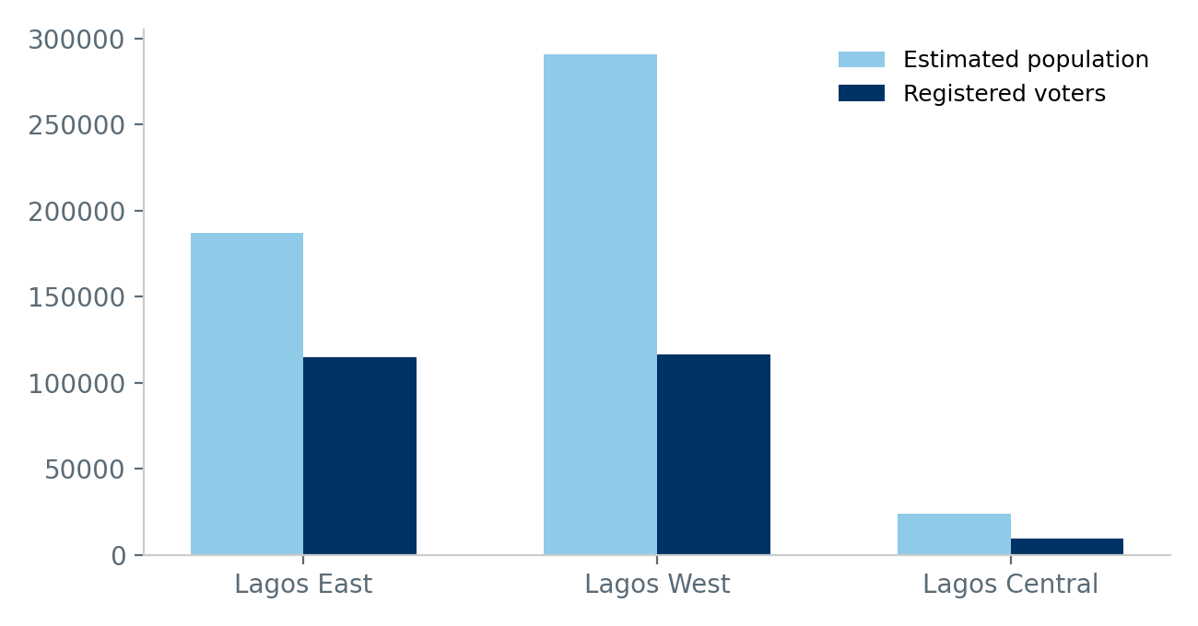

The gap between the population bar and the voters bar in each district is the addressable registration opportunity. In Lagos West alone, this gap represents an estimated 174,437 residents who are not currently registered voters. Closing even a portion of this gap through the mobile registration approach recommended in Part 3 converts directly into a larger, more representative electorate across exactly the communities this report covers.

4.4 Why the PVC Barrier Matters Here Specifically
Part 3 established that 86.6% of communities cite cost, distance, or both as their main barrier to obtaining a PVC. Layered against the registration-rate data in this section, that barrier is not evenly distributed: it is most severe in exactly the district, Lagos West, that already has the lowest registration rate and the largest unregistered population. The two findings reinforce each other rather than standing separately, and together they make Lagos West the clearest single target for a mobile PVC and NIN registration program among the three districts.

Part 5 — Community Need-Clusters and Spatial Patterns
Ranking communities on any single indicator, network coverage, or health access, or sanitation, tells only part of the story, because these deprivations do not distribute independently of each other. To see the actual shape of need across the 134 surveyed communities, this section groups them by their combined profile across all thirteen deprivation indicators used throughout this report, rather than by geography or by any one measure alone.
Four distinct groups emerge from this analysis. They are not simply "worse" and "better" versions of each other; each has a different binding constraint, which means each requires a different lead intervention rather than a single state-wide program applied uniformly.

5.1 The Four Community Clusters
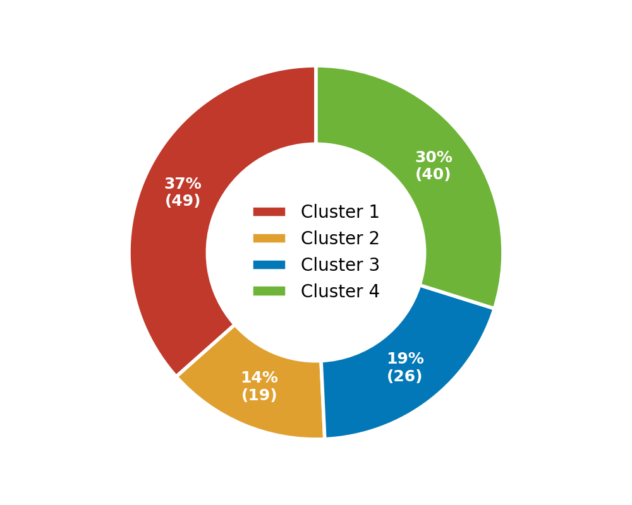 | 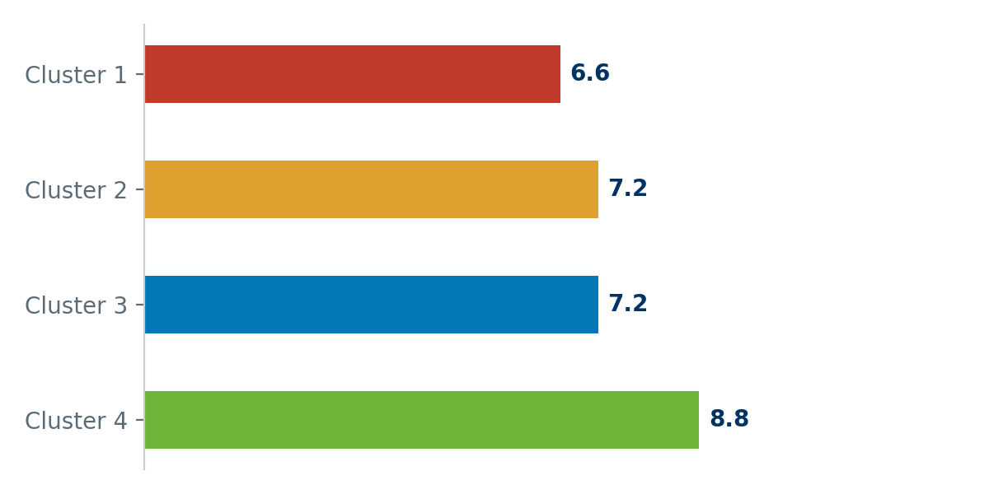

Cluster 1 — Digitally Cut-Off Corridor
49 communities • Avg. population 3,480 • Avg. severity 6.6 of 13
Forty-nine communities, entirely within Lagos East, defined above all by voice-only network coverage, universal absence of any prior government or NGO contact, and a near-universal PVC access barrier. Health access is almost entirely absent. This is a single-district, single-cause-led cluster: fixing connectivity here does more to change this group’s profile than any other single intervention.
Example communities: Abegede, Abejoye, Agadamgba, Ajegunle, Alawofun

Cluster 2 — Institutionally Under-Governed Belt
19 communities • Avg. population 4,472 • Avg. severity 7.2 of 13
Nineteen communities, concentrated in Lagos West with a smaller presence in Lagos East and Lagos Central, defined by universal absence of an evacuation plan and prior government contact, alongside a near-universal absence of health access. Unlike the network-cut cluster, connectivity is not the binding constraint here; institutional and civic infrastructure is.
Example communities: Apa, Bishop Kodji, Ibasa, Igbo elejo, Igbo olobi

Cluster 3 — Larger, Under-Serviced Peri-Urban Cluster
26 communities • Avg. population 5,198 • Avg. severity 7.2 of 13
Twenty-six communities with the largest average population of any cluster, mostly in Lagos West, defined by near-universal absence of an evacuation plan alongside significant sanitation and education gaps. These are larger, more established communities where safety and schooling infrastructure lags well behind population size.
Example communities: Abule Osun, Agaja, Agonu, Dadi Louis, Egon

Cluster 4 — Broadest Multi-Deprivation Cluster
40 communities • Avg. population 2,783 • Avg. severity 8.8 of 13
Forty communities spanning both Lagos West and Lagos East, the only cluster that crosses both districts in meaningful numbers, and carrying the highest average severity score of the four. Nearly every community here lacks formal health access, has never been reached by government or an NGO, and has no education facility beyond primary level simultaneously. This is the broadest, most acute combination of unmet needs in the dataset.
Example communities: Aba keta, Aba oyinbo, Abatuntun, Abomiti, Abureji

5.2 What the Clusters Mean for Sequencing
Cluster 4 carries the highest average severity score of any group and is the only cluster with a meaningful presence in both Lagos East and Lagos West, making it the largest single target by community count for a government office prioritizing acute, multi-dimensional need. Cluster 1, the digitally cut-off corridor, is the cluster where a single infrastructure fix, network coverage, plausibly changes the largest share of that cluster’s profile at once, since so many of its other gaps (registration access, formal service access) trace back to the same root cause. Clusters 2 and 3 carry more population per community and a narrower, more specific set of gaps each, making them better suited to a themed program, institutional and civic outreach for Cluster 2, disaster preparedness and schooling for Cluster 3, than to a single flagship intervention.

5.3 Spatial Patterns
Precise coordinates are available for 120 of the 134 surveyed communities, sufficient to test whether a community’s position within its Local Government Area relates to its severity score. Communities located further from their Local Government Area’s geographic center average a severity score of 7.96, compared to 7.34 for communities closer to that center, a modest gap consistent with the intuitive pattern that more peripheral settlements are harder to reach with services.
The overall statistical relationship between distance and severity across the mapped sample is weak (correlation coefficient 0.037), which is itself an informative finding: physical remoteness within a Local Government Area is not the main driver of which communities are underserved. Cluster membership, documented above, is a far stronger predictor than geographic position alone. In practice, this means a purely map-based prioritization, "reach the farthest community first", would miss most of the highest-severity communities identified in this report, which are often close to a Local Government Area’s center but simply never reached.

5.4 — Community Severity Overlaid on Elevation and LGA Boundaries
This is the primary evidence map. Each of the seven focus LGAs is outlined in its own color, with dots marking every community that has been geolocated to date, color-coded by the same severity score used throughout Part 7 of the report: red for critical (severity 9 to 13), orange for high (6 to 8), green for moderate (2 to 5).
Of the 120 geolocated communities shown, 24 fall into the critical band and 59 into the high band 89% of mapped communities carry a meaningful, multi-indicator deprivation profile. Visually, the heaviest concentration of red and orange points sits inside the same low-elevation, erosion-exposed zone identified in Map 1, in Epe and Ibeju-Lekki. This is the clearest single visual argument in the report: the communities furthest from government reach are also, independently, the ones sitting in the most physically exposed terrain.
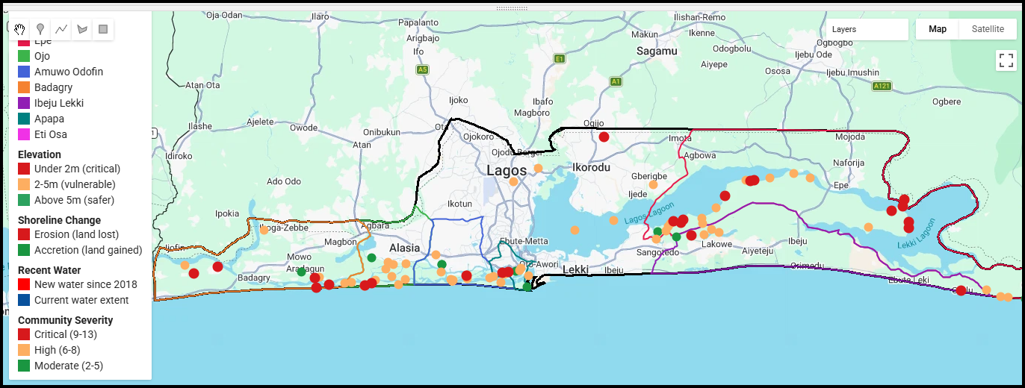
Figure 2. Community severity points over elevation, shoreline change, and recent water layers, with all seven focus LGA boundaries shown.

As the remaining 14 communities complete field geolocation, this spatial layer can be extended into a full choropleth map at community level, cross-referenced against the cluster assignments above, to support site-level intervention planning directly.

Part 6 — Cross-Factor Analysis: What Drives What
Part 3 reports each deprivation indicator on its own. This section tests specific pairs of indicators against each other directly, to establish which deprivations tend to travel together and by how much, rather than assuming a connection because two problems sound related. The measure used throughout is lift: how much more likely a community is to have the second problem, given that it already has the first, compared to the base rate of that second problem across all communities. A lift of 1.0 means no added risk; a lift above 1.0 means the two problems compound.

6.1 Where Deprivations Compound
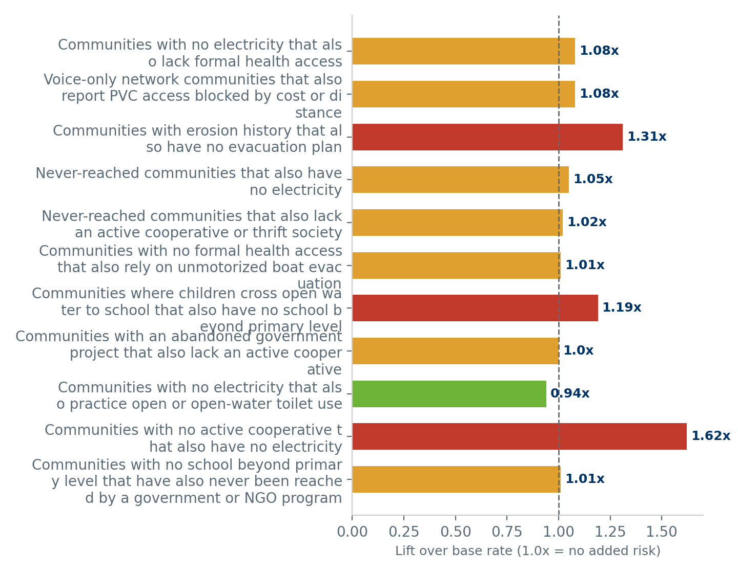

Relationship | Base Rate | Conditional Rate | Lift | Communities (n)
Communities with no electricity that also lack formal health access | 31.3% | 33.9% | 1.08x | 112
Voice-only network communities that also report PVC access blocked by cost or distance | 43.3% | 46.6% | 1.08x | 116
Communities with erosion history that also have no evacuation plan | 63.4% | 83.3% | 1.31x | 30
Never-reached communities that also have no electricity | 91% | 95.2% | 1.05x | 42
Never-reached communities that also lack an active cooperative or thrift society | 50% | 50.8% | 1.02x | 122
Communities with no formal health access that also rely on unmotorized boat evacuation | 80.6% | 81.2% | 1.01x | 112
Communities where children cross open water to school that also have no school beyond primary level | 80.6% | 95.7% | 1.19x | 23
Communities with an abandoned government project that also lack an active cooperative | 14.9% | 14.9% | 1x | 67
Communities with no electricity that also practice open or open-water toilet use | 81.3% | 76.2% | 0.94x | 42
Communities with no active cooperative that also have no electricity | 31.3% | 50.7% | 1.62x | 67
Communities with no school beyond primary level that have also never been reached by a government or NGO program | 91% | 91.7% | 1.01x | 108

6.2 Reading the Strongest Relationships
The clearest compounding effect in this dataset is between erosion history and disaster preparedness: communities that have already lost land or housing to riverbank erosion are 83.3% likely to also have no evacuation plan, well above the 63.4% base rate. In practical terms, the communities with direct, lived evidence that this risk is real are, if anything, slightly less prepared for the next event than communities with no erosion history at all.
A similar pattern holds for education and safety: in communities where children already cross open water without a bridge to reach school, 95.7% also have no education facility beyond primary level, meaning the children making that hazardous crossing today are disproportionately likely to have nowhere further to advance to locally once they arrive.
Electricity access shows a real but more moderate compounding effect with health access: communities with no formal first-aid access are 33.9% likely to also have no electricity, against a 31.3% base rate, consistent with the practical reality that a health post without power cannot refrigerate medicine or run at night.
The strongest single relationship in this dataset links social infrastructure to physical infrastructure directly: communities with no active cooperative or thrift society are 50.7% likely to also have no electricity, a lift of 1.62x over the base rate. This is the clearest evidence in the dataset that these gaps are not randomly distributed across communities, but concentrated in a specific subset that is missing both economic and physical infrastructure together, the profile that defines Cluster 2 in Part 5.

6.3 Where the Data Does Not Support a Link
Not every plausible-sounding relationship holds up. Communities with an abandoned past government project are not meaningfully more or less likely to also lack an active cooperative society, and communities with no electricity are not meaningfully more likely to use open or open-water toilets than communities with electricity. Communities with no school beyond primary level are also no more or less likely than any other community to have been reached by a prior government or NGO program, a lift of almost exactly 1.0x. All three relationships sit close to a lift of 1.0, meaning these particular deprivations appear to have independent causes rather than a shared one, and should be budgeted and addressed as separate line items rather than assumed to resolve together.

6.4 Implication for Intervention Design
The practical use of this section is negative as much as positive: it tells a planning office which single interventions are likely to have knock-on benefits, and which will not. An evacuation-planning program targeted at erosion-affected communities addresses a compounded risk, not just an isolated gap. A cooperative-revival program, by contrast, needs to be planned and funded on its own merits; it will not be resolved as a side effect of infrastructure spending elsewhere.

Part 7 — District Deep Dive
This section lists every surveyed community by senatorial district and Local Government Area, ranked by severity score — a composite of thirteen deprivation indicators covering health access, electricity, network coverage, disaster preparedness, education, sanitation, and prior government presence. A higher score marks a community with a wider combination of unmet needs.

● Severity 9-13 — Critical | ● Severity 6-8 — High | ● Severity 2-5 — Moderate

7.1 Lagos East
Lagos East covers 75 communities across 2 Local Government Areas (Epe, Ibeju Lekki), with an estimated population of 187,018. Its most severe single indicator is "No formal first-aid access point in community (traditional or none)", affecting 97.3% of its communities, while its strongest indicator is "Past government project abandoned in community" at 9.3%. The dominant community need-cluster from Part 5 within this district is Cluster 1, accounting for 49 of its 75 communities.

75  Communities | 187,018  Estimated Population | 2  LGAs | 14  Critical-Severity Communities

Epe LGA — 66 communities
Epe carries an estimated population of 175,273 across its 66 surveyed communities, with an average severity score of 7.3 of 13. 13 of its communities fall into the critical band (severity 9 or above), led by Imougo at a severity score of 11.
Community | Pop. | Sev. | Health Access | Electricity | Network | Evac Plan | Needs Jetty
Imougo | 525 | 11 | Traditional | None | Voice only | None | Yes
Ito osun | 187 | 11 | Traditional | None | Voice only | None | Yes
Ladega | 250 | 11 | Traditional | None | Voice only | None | Yes
Aba oyinbo | 100 | 10 | Traditional | Generator | 4G Data | None | Yes
Abomiti | 625 | 10 | Traditional | Generator | 4G Data | None | No
Emina | 562 | 10 | Traditional | Generator | Voice only | None | Yes
Isan | 1,749 | 10 | Traditional | Generator | Voice only | None | Yes
Moyopa | 250 | 10 | Traditional | Generator | Voice only | None | Yes
Abatuntun | 62 | 9 | None | None | 4G Data | None | Yes
Idi Afon | 250 | 9 | Traditional | None | 4G Data | Inactive | Yes
Moro | 187 | 9 | Traditional | None | 4G Data | None | Yes
Oguntedo | 2,498 | 9 | Traditional | Generator | Voice only | None | Yes
Oriba | 874 | 9 | Traditional | None | 4G Data | None | Yes
Aba keta | 50 | 8 | Traditional | None | 4G Data | Inactive | Yes
Adepale | 75 | 8 | None | None | 4G Data | None | Yes
Bodun | 187 | 8 | None | None | 4G Data | None | Yes
Ibon | 625 | 8 | Traditional | Generator | Voice only | Inactive | Yes
Igbodu Waterside | 125 | 8 | Traditional | None | 4G Data | None | Yes
Ipesu | 250 | 8 | Traditional | Generator | Voice only | Inactive | Yes
Okotiye | 62 | 8 | None | None | 4G Data | None | Yes
Olorushogo | 3,124 | 8 | Traditional | Generator | Voice only | None | Yes
Oregun | 812 | 8 | Traditional | Generator | Voice only | Inactive | Yes
Oriogoro | 1,499 | 8 | None | None | 4G Data | None | Yes
Saga | 1,874 | 8 | Traditional | Generator | 4G Data | None | Yes
Yegunda | 950 | 8 | Traditional | Generator | Voice only | Inactive | Yes
Agadamgba | 2,498 | 7 | Traditional | Generator | Voice only | Inactive | Yes
Ebute Kosu | 4,414 | 7 | Traditional | Generator | Voice only | Inactive | Yes
Idomu | 4,563 | 7 | Traditional | Generator | Voice only | Inactive | Yes
Ikeran | 4,262 | 7 | Traditional | Generator | Voice only | Inactive | Yes
Ilamija Kekere | 2,498 | 7 | Traditional | Generator | Voice only | Inactive | Yes
Imeki Ebute | 4,534 | 7 | Traditional | Generator | Voice only | Inactive | Yes
Luboye | 1,124 | 7 | Traditional | Generator | Voice only | Inactive | Yes
Mudana Ogidi | 4,897 | 7 | Traditional | Generator | Voice only | Inactive | Yes
Mudana Seriki | 6,462 | 7 | Traditional | Generator | Voice only | Inactive | Yes
Okokeji | 437 | 7 | Traditional | Generator | Voice only | Inactive | Yes
Okorisan | 6,532 | 7 | Traditional | Generator | Voice only | Inactive | Yes
Olosho | 4,900 | 7 | Traditional | Generator | Voice only | Inactive | Yes
Onigbagbo | 5,238 | 7 | Traditional | Generator | Voice only | Inactive | Yes
Onijiga | 312 | 7 | Traditional | Generator | Voice only | Inactive | Yes
Orepete | 375 | 7 | Traditional | Generator | Voice only | Inactive | Yes
Abejoye | 5,534 | 6 | Traditional | Generator | Voice only | Inactive | Yes
Ajegunle | 4,536 | 6 | Traditional | Generator | Voice only | Inactive | Yes
Alawofun | 437 | 6 | Traditional | Generator | Voice only | Inactive | Yes
Anwoye | 125 | 6 | Traditional | Generator | Voice only | Active | No
Arafa | 7,534 | 6 | Traditional | Generator | Voice only | Inactive | Yes
Ayesan | 4,535 | 6 | Traditional | Generator | Voice only | Inactive | Yes
Ereshe | 4,449 | 6 | Traditional | Generator | Voice only | Inactive | Yes
Fowotera | 4,980 | 6 | Traditional | Generator | Voice only | Inactive | Yes
Igbo Apawa | 8,253 | 6 | Traditional | Generator | Voice only | Inactive | Yes
Ijayo | 4,932 | 6 | Traditional | Generator | Voice only | Inactive | Yes
Ilamija Nla | 1,874 | 6 | Traditional | Generator | Voice only | Inactive | Yes
Imafon | 4,256 | 6 | Traditional | Generator | Voice only | Inactive | Yes
Imeki Oloye | 4,563 | 6 | Traditional | Generator | Voice only | Inactive | Yes
Ladaba | 2,498 | 6 | Traditional | Generator | Voice only | None | Yes
Ladaba Ebute | 375 | 6 | Traditional | Generator | Voice only | Inactive | Yes
Mejona | 2,498 | 6 | Traditional | Generator | Voice only | Inactive | Yes
Odupeyin | 4,041 | 6 | Traditional | Generator | Voice only | Inactive | Yes
Ofin Jango | 5,243 | 6 | Traditional | Generator | Voice only | Inactive | Yes
Ogbun | 4,538 | 6 | Traditional | Generator | Voice only | Inactive | Yes
Oke Oko | 4,041 | 6 | Traditional | Generator | Voice only | Inactive | Yes
Olatunji Ikeran | 4,451 | 6 | Traditional | Generator | Voice only | Inactive | Yes
Olorunkoya | 4,235 | 6 | Traditional | Generator | Voice only | Inactive | Yes
Take Nla | 6,562 | 6 | Traditional | Generator | Voice only | Inactive | Yes
Abureji | 250 | 5 | Traditional | None | 4G Data | None | Yes
Ito Omu | 2,373 | 5 | Mobile worker | Grid | 4G Data | None | No
Oko Abe | 8,000 | 5 | Traditional | Generator | Voice only | Inactive | Yes

Ibeju Lekki LGA — 9 communities
Ibeju Lekki carries an estimated population of 11,745 across its 9 surveyed communities, with an average severity score of 7.2 of 13. 1 of its communities fall into the critical band (severity 9 or above), led by Ikegun at a severity score of 9.
Community | Pop. | Sev. | Health Access | Electricity | Network | Evac Plan | Needs Jetty
Ikegun | 999 | 9 | None | None | 4G Data | None | Yes
Abegede | 375 | 8 | Traditional | Generator | Voice only | None | Yes
Ilogbo village | 187 | 8 | Traditional | None | 4G Data | None | Yes
Arapagi lotu | 2,498 | 7 | Traditional | Generator | Voice only | None | Yes
Dongo | 375 | 7 | Traditional | Generator | Voice only | Active | Yes
Idiori | 1,624 | 7 | Traditional | Generator | Voice only | Inactive | Yes
Imedu village | 62 | 7 | Traditional | Solar | 4G Data | None | Yes
Okunlape | 625 | 7 | Traditional | Generator | 4G Data | Active | Yes
Arapagi wajoba | 5,000 | 5 | Chemist | Grid | Voice only | Inactive | Yes

7.2 Lagos West
Lagos West covers 56 communities across 3 Local Government Areas (Amuwo Odofin, Ojo, Badagry), with an estimated population of 290,987. Its most severe single indicator is "Communities with no emergency evacuation point or committee", affecting 98.2% of its communities, while its strongest indicator is "Communities with voice-only network (no data or 4G)" at 3.6%. The dominant community need-cluster from Part 5 within this district is Cluster 4, accounting for 21 of its 56 communities.

56  Communities | 290,987  Estimated Population | 3  LGAs | 19  Critical-Severity Communities

Amuwo Odofin LGA — 17 communities
Amuwo Odofin carries an estimated population of 106,113 across its 17 surveyed communities, with an average severity score of 7.2 of 13. 3 of its communities fall into the critical band (severity 9 or above), led by Ilado Odo and Inagbe Island at a severity score of 10.
Community | Pop. | Sev. | Health Access | Electricity | Network | Evac Plan | Needs Jetty
Ilado Odo and Inagbe Island | 4,997 | 10 | None | None | 4G Data | None | No
Imore | 8,000 | 10 | Traditional | Grid | 4G Data | None | No
Ito Agan comminity | 5,000 | 9 | Traditional | None | 4G Data | None | Yes
Bishop Kodji | 5,000 | 8 | Traditional | Grid | 4G Data | None | No
Ibasa | 10,000 | 8 | Traditional | Grid | 4G Data | None | No
Ikaare | 10,000 | 8 | Chemist | Grid | 4G Data | None | Yes
Inogbe | 6,003 | 8 | Traditional | None | 4G Data | None | Yes
Sagbokodji Community | 3,248 | 8 | Traditional | Grid | 4G Data | None | No
Ilashe | 1,874 | 7 | Traditional | Grid | 4G Data | None | No
Ogogoro Village | 15,000 | 7 | Traditional | None | 4G Data | Active | Yes
Igbo elejo | 4,997 | 6 | Traditional | Grid | 4G Data | None | No
Igboeseyore | 4,997 | 6 | Traditional | Grid | 4G Data | None | No
Igbologun | 7,000 | 6 | Traditional | Grid | 4G Data | None | Yes
Igubo isu | 5,000 | 6 | Traditional | Grid | 4G Data | None | Yes
Iyagbe | 4,997 | 6 | Traditional | Grid | 4G Data | None | No
Abule Osun | 5,000 | 5 | Mobile worker | Grid | 4G Data | None | No
Ibeshe | 5,000 | 5 | Mobile worker | Grid | 4G Data | None | No

Ojo LGA — 29 communities
Ojo carries an estimated population of 132,881 across its 29 surveyed communities, with an average severity score of 7.9 of 13. 11 of its communities fall into the critical band (severity 9 or above), led by Alemou at a severity score of 9.
Community | Pop. | Sev. | Health Access | Electricity | Network | Evac Plan | Needs Jetty
Alemou | 1,249 | 9 | Traditional | None | 4G Data | None | Yes
Dadidi | 4,372 | 9 | Traditional | None | 4G Data | None | Yes
Igamo | 3,747 | 9 | Traditional | None | 4G Data | None | Yes
Igbo Oja Nla | 375 | 9 | Traditional | Grid | 4G Data | None | Yes
Ikotun | 4,997 | 9 | Traditional | None | 4G Data | None | Yes
Ojorin | 3,747 | 9 | Traditional | None | 4G Data | None | Yes
Okoogbo | 4,997 | 9 | Traditional | None | 4G Data | None | Yes
Origbogbo | 3,747 | 9 | Traditional | None | 4G Data | None | Yes
Petepete | 4,372 | 9 | Traditional | None | 4G Data | None | Yes
Popokun | 4,622 | 9 | Traditional | None | 4G Data | None | Yes
Sodanu | 4,997 | 9 | Traditional | None | 4G Data | None | Yes
Agaja | 4,997 | 8 | Mobile worker | None | 4G Data | None | Yes
Agonu | 3,747 | 8 | Chemist | Grid | 4G Data | None | Yes
Egon | 2,498 | 8 | Chemist | Grid | 4G Data | None | Yes
Ese Ofin | 10,000 | 8 | None | Grid | 4G Data | None | No
Moba | 4,997 | 8 | Chemist | Grid | 4G Data | None | Yes
Ojota | 13,000 | 8 | Traditional | Grid | 4G Data | None | Yes
Okoagbado | 4,500 | 8 | Traditional | None | 4G Data | None | Yes
Erekun | 2,498 | 7 | Mobile worker | Solar | 4G Data | None | Yes
Igbo Oja kekere | 312 | 7 | Chemist | Grid | 4G Data | None | Yes
Igbo olobi | 3,747 | 7 | Traditional | None | 4G Data | None | No
Irede | 7,000 | 7 | Traditional | Grid | 4G Data | None | No
Irewe | 4,997 | 7 | None | Grid | 4G Data | None | No
Ishagira | 2,498 | 7 | Chemist | Grid | 4G Data | None | Yes
Okolundu | 4,997 | 7 | Traditional | None | 4G Data | None | Yes
Origele | 5,000 | 7 | Traditional | None | 4G Data | None | Yes
Orufo | 4,997 | 7 | Traditional | None | 4G Data | None | No
Taffi | 1,874 | 7 | Chemist | Grid | 4G Data | None | Yes
Idoluwo | 10,000 | 5 | Chemist | Solar | 4G Data | None | Yes

Badagry LGA — 10 communities
Badagry carries an estimated population of 51,993 across its 10 surveyed communities, with an average severity score of 8.2 of 13. 5 of its communities fall into the critical band (severity 9 or above), led by Apa at a severity score of 10.
Community | Pop. | Sev. | Health Access | Electricity | Network | Evac Plan | Needs Jetty
Apa | 625 | 10 | Traditional | Generator | Voice only | None | Yes
Igbogbele | 5,000 | 10 | Traditional | None | 4G Data | None | No
Ajido | 5,000 | 9 | Traditional | None | 4G Data | None | Yes
Dadi Louis | 2,498 | 9 | Chemist | None | 4G Data | None | Yes
Jegeme | 3,123 | 9 | Mobile worker | None | Voice only | None | Yes
Iworo | 3,747 | 8 | Chemist | Grid | 4G Data | None | Yes
Povita | 5,000 | 8 | Traditional | Grid | 4G Data | None | Yes
Erekiti | 10,000 | 7 | Chemist | Grid | 4G Data | None | No
Kese | 7,000 | 7 | Chemist | Generator | 4G Data | None | Yes
Iyafin | 10,000 | 5 | Chemist | Grid | 4G Data | None | No

7.3 Lagos Central
Lagos Central covers 3 communities across 2 Local Government Areas (Apapa, Eti Osa), with an estimated population of 23,997. Its most severe single indicator is "Communities with no emergency evacuation point or committee", affecting 100% of its communities, while its strongest indicator is "Communities with voice-only network (no data or 4G)" at 0%. The dominant community need-cluster from Part 5 within this district is Cluster 2, accounting for 1 of its 3 communities.

3  Communities | 23,997  Estimated Population | 2  LGAs | 1  Critical-Severity Communities

Apapa LGA — 2 communities
Apapa carries an estimated population of 16,997 across its 2 surveyed communities, with an average severity score of 6.5 of 13. 1 of its communities fall into the critical band (severity 9 or above), led by Nanti at a severity score of 9.
Community | Pop. | Sev. | Health Access | Electricity | Network | Evac Plan | Needs Jetty
Nanti | 4,997 | 9 | Traditional | None | 4G Data | None | Yes
Irede Onisiwo, Apapa Quays | 12,000 | 4 | Chemist | Generator | 4G Data | None | Yes

Eti Osa LGA — 1 community
Eti Osa carries an estimated population of 7,000 across its 1 surveyed communities, with an average severity score of 5.0 of 13. No community in this LGA falls into the critical severity band, though the table below shows several with meaningful, specific gaps worth addressing.
Community | Pop. | Sev. | Health Access | Electricity | Network | Evac Plan | Needs Jetty
Tarkwa bay | 7,000 | 5 | Mobile worker | None | 4G Data | None | Yes

Part 8 — Recommendations and Call to Action
The findings in Parts 3 through 7 point to a consistent conclusion: these communities are not asking for isolated favors, they are missing the basic civic infrastructure that the rest of Lagos State takes for granted, and the pattern of that missing infrastructure is now well enough understood to plan against directly. The recommendations below are organized first by implementation horizon, then mapped to the specific community clusters from Part 5 that each recommendation targets most directly.

8.1 Immediate: Zero to Six Months
- Deploy mobile health outreach and immunisation teams to the highest-severity communities identified in Part 7, starting with Cluster 4 (Broadest Multi-Deprivation Cluster), where health access is weakest relative to population reached and both districts are represented.
- Run mobile PVC and NIN registration drives directly in Lagos West Local Government Areas first, using the registration-rate table in Part 4 to sequence by Local Government Area rather than by district.
- Establish community disaster committees and designate evacuation points in Lagos West and Lagos Central, and specifically in erosion-affected communities identified in Part 6, where the compounding risk is highest.

8.2 Medium-Term: Six to Eighteen Months
- Fund motorized boat ambulances for the riverine communities of Epe and Ibeju-Lekki Local Government Areas, where unmotorized-boat medical evacuation is most concentrated.
- Extend 4G network infrastructure to Cluster 1 (Digitally Cut-Off Corridor) communities in Lagos East, the single highest-leverage infrastructure investment identified in this report given how many other gaps in that cluster trace back to connectivity.
- Invest in basic electricity access, through grid extension or solar mini-grids, prioritizing Cluster 2 (Institutionally Under-Governed Belt) communities in Lagos West, where the electricity gap compounds most strongly with health access per Part 6.

8.3 Long-Term: Eighteen Months and Beyond
- Commission a school-access program, covering secondary school construction, transport, or safe pedestrian bridges, targeting Cluster 3 (Larger, Under-Serviced Peri-Urban Cluster) communities, where population per community is largest and the education gap affects the most students per site.
- Formalize sanitation infrastructure, including shared or flush toilets and managed waste collection, in communities currently relying on open or open-water defecation, cross-referenced against the LGA-level tables in Part 3.
- Support cooperative and thrift society formation, building on already-established Esusu and Ajo traditions, as a low-cost channel for community economic resilience, particularly across Cluster 2 in Lagos West.

8.4 Recommendation-to-Cluster Reference
Cluster | Lead Constraint | Priority Recommendation
Cluster 1: Digitally Cut-Off Corridor | Network connectivity | 4G network extension (8.2)
Cluster 2: Institutionally Under-Governed Belt | Institutional and civic infrastructure | Evacuation planning and civic outreach (8.1, 8.3)
Cluster 3: Larger, Under-Serviced Peri-Urban Cluster | Evacuation planning and schooling at scale | School access and evacuation planning (8.1, 8.3)
Cluster 4: Broadest Multi-Deprivation Cluster | Broadest, cross-district compounding neglect | Mobile health outreach (8.1)

8.5 The Cost of Inaction
91% of these 134 communities have never been reached by any government program. Left unaddressed, the gaps documented in this report compound in the way Part 6 demonstrates directly: children without secondary schools become adults without formal employment options, communities without evacuation plans absorb disaster losses that could have been mitigated, and residents without civic registration remain invisible in planning and budgeting cycles that depend on that same data. Every recommendation above is scoped against a population of 502,002 residents and 241,053 registered voters who are already Lagos State residents, already contributing to its economy through the fishing, farming, and trading livelihoods documented in Part 3, and already asking, through this survey, to be counted.

8.6 Suggested Monitoring Indicators
Because every recommendation in this report is anchored to a specific measured indicator, progress against it can be tracked using the same survey structure rather than a new evaluation framework. A practical monitoring set, to be re-measured on a fixed cycle against the same 134-community register:
- Voter registration rate by Local Government Area, tracked against the Part 4 baseline of 48% overall.
- Share of communities with no formal first-aid access point, tracked against the Part 3 baseline of 83.6%.
- Share of communities with a designated evacuation point or active disaster committee, tracked against the Part 3 baseline of 36.6%.
- Share of communities with 4G or data network coverage, tracked against the Part 3 baseline of 56.7%.
- Average severity score per cluster, tracked against the Part 5 baselines, to confirm that intervention is narrowing the gap between the least and most deprived clusters rather than only improving the average.

8.7 Funding and Partnership Considerations
Blue Lagos Initiatives has built the community relationships, the named local contact structure described in Part 2.3, and the survey infrastructure behind this report, and is positioned to continue as the implementation and monitoring partner for any government-funded intervention that follows from it. This report is offered as the evidence base for that partnership discussion, structured so that funding can be allocated against specific, measurable indicators rather than general need, and tracked over time using the same community register.

Appendix

A.1 Glossary of Indicators
Severity Score: a composite count, from 0 to 13, of how many of the thirteen deprivation indicators used in Part 5, 6, and 7 apply to a given community. A higher score indicates a wider combination of unmet needs, not a single worse problem.
Lift: used in Part 6 to describe how much more likely a community is to have one deprivation given that it already has another, compared to that deprivation’s base rate across all communities. A lift of 1.0 means no added risk; higher values indicate compounding.
Registration Rate: registered voters as a percentage of estimated community population, used throughout Part 4 as the primary civic-reach measure.
Community Cluster: one of four groups produced by classifying every community across all thirteen deprivation indicators simultaneously, described in full in Part 5.

A.2 Cluster Membership Summary
Cluster | Communities | Avg. Population | Avg. Severity
Cluster 1: Digitally Cut-Off Corridor | 49 | 3,480 | 6.6
Cluster 2: Institutionally Under-Governed Belt | 19 | 4,472 | 7.2
Cluster 3: Larger, Under-Serviced Peri-Urban Cluster | 26 | 5,198 | 7.2
Cluster 4: Broadest Multi-Deprivation Cluster | 40 | 2,783 | 8.8

A.3 Survey Instrument: Full Indicator List
Data was collected across the following domains for each community, using fixed-category responses throughout so findings could be aggregated consistently. This is the complete indicator set behind every table and chart in this report.

Domain | Indicators Collected
Identification and Location | Community name, LGA, and senatorial district; Community ruler or head title and name; Primary visit route; GPS coordinates (where captured)
Demographics | Estimated total population; Household population estimate; Estimated registered voters; Estimated number of women, youth (18 to 35), and pregnant women
Civic Access | Existing and priority-needed community amenities; Main challenges obtaining a PVC; Share of residents holding NIN; Main challenges obtaining NIN; Difficulty reaching the nearest registration center
Health and Emergency Response | Primary first-aid access point in the absence of a formal health center; Primary mode of medical evacuation during an emergency; Immunisation team visits in the last 12 months; Mode of immunisation service delivery; Frequency of immunisation team visits; Perceived coverage of eligible children; Main challenges accessing immunisation services
Education | Highest level of education physically available in the community; Whether children cross open water or major routes without a bridge to reach school
Water, Sanitation, and Waste | Primary everyday drinking water source; Primary household toilet facility; Predominant solid waste disposal method; Duration of floodwater stagnation during peak rainy season
Housing and Structural Resilience | Dominant wall construction material; History of land or housing loss to riverbank erosion in the last five years; Presence of a designated evacuation point or disaster committee
Economy and Livelihoods | Primary occupation; Primary economic role of women in the community; Dominant daily activity of young adults (18 to 35); Biggest barrier to selling agricultural or fish catch; Food security strategy during the off-season or severe weather
Connectivity and Infrastructure | Mobile network coverage status (voice or data); Primary source of electricity for lighting; Physical condition of the main boat landing area; Top channels through which residents receive information
Security and Governance | Primary channel for reporting security incidents or resolving disputes; Presence of an active cooperative or thrift society (Esusu or Ajo); State of past government presence and project status

A.4 Full Community Register
The complete underlying dataset of all 134 communities, including every field collected, the severity score, and cluster assignment for each community, accompanies this report as a separate spreadsheet.

A.5 Community Engagement Records
Blue Lagos Initiatives maintains an ongoing engagement record for each community in this register, including named local contacts and any follow-up activity since the initial survey. This engagement history can be appended to this report as a further annex where it strengthens the case for a specific community or Local Government Area.

A.6 Consolidated Indicator Reference Sheet
A single-page lookup of every headline figure used across this report, for quick reference without paging back through each part.

Indicator | Overall | Report Reference
Communities surveyed | 134 | Part 1.3
Estimated population reached | 502,002 | Part 1.3
Registered voters | 241,053 | Part 1.3 and Part 4
Voter registration rate | 48% | Part 4.1
No prior NGO or government program | 91% | Part 3.8
No formal first-aid access point | 83.6% | Part 3.3
Rely on unmotorized or no medical evacuation | 80.6% | Part 3.3
Voice-only network, no data or 4G | 43.3% | Part 3.5
No electricity source | 31.3% | Part 3.5
No school beyond primary level | 93.1% | Part 3.6
Open or open-water toilet use | 81.3% | Part 3.4
PVC access blocked by cost or distance | 86.6% | Part 3.2
No evacuation point or disaster committee | 63.4% | Part 3.9
Erosion-affected in the last five years | 22.4% | Part 3.9
No active cooperative or thrift society | 50% | Part 3.7
Community need-clusters identified | 4 | Part 5
Communities geolocated | 120 of 134 | Part 2.6

A.7 Full Community-to-Cluster Assignment
Every surveyed community, listed with its Local Government Area, senatorial district, and the need-cluster from Part 5 it was assigned to. This is the community-level detail behind the cluster summaries in Part 5 and the cluster-targeted recommendations in Part 8.

Community | LGA | District | Cluster
Sagbokodji Community | Amuwo Odofin | Lagos West | 2: Under-Governed Belt
Ogogoro Village | Amuwo Odofin | Lagos West | 4: Multi-Deprivation
Iyagbe | Amuwo Odofin | Lagos West | 2: Under-Governed Belt
Ito Agan comminity | Amuwo Odofin | Lagos West | 4: Multi-Deprivation
Inogbe | Amuwo Odofin | Lagos West | 4: Multi-Deprivation
Imore | Amuwo Odofin | Lagos West | 3: Peri-Urban Cluster
Ilashe | Amuwo Odofin | Lagos West | 2: Under-Governed Belt
Ilado Odo and Inagbe Island | Amuwo Odofin | Lagos West | 4: Multi-Deprivation
Ikaare | Amuwo Odofin | Lagos West | 3: Peri-Urban Cluster
Igubo isu | Amuwo Odofin | Lagos West | 2: Under-Governed Belt
Igbologun | Amuwo Odofin | Lagos West | 2: Under-Governed Belt
Igboeseyore | Amuwo Odofin | Lagos West | 2: Under-Governed Belt
Igbo elejo | Amuwo Odofin | Lagos West | 2: Under-Governed Belt
Ibeshe | Amuwo Odofin | Lagos West | 3: Peri-Urban Cluster
Ibasa | Amuwo Odofin | Lagos West | 2: Under-Governed Belt
Bishop Kodji | Amuwo Odofin | Lagos West | 2: Under-Governed Belt
Abule Osun | Amuwo Odofin | Lagos West | 3: Peri-Urban Cluster
Nanti | Apapa | Lagos Central | 4: Multi-Deprivation
Irede Onisiwo, Apapa Quays | Apapa | Lagos Central | 3: Peri-Urban Cluster
Povita | Badagry | Lagos West | 4: Multi-Deprivation
Kese | Badagry | Lagos West | 3: Peri-Urban Cluster
Jegeme | Badagry | Lagos West | 4: Multi-Deprivation
Iyafin | Badagry | Lagos West | 3: Peri-Urban Cluster
Iworo | Badagry | Lagos West | 3: Peri-Urban Cluster
Igbogbele | Badagry | Lagos West | 4: Multi-Deprivation
Erekiti | Badagry | Lagos West | 3: Peri-Urban Cluster
Dadi Louis | Badagry | Lagos West | 3: Peri-Urban Cluster
Apa | Badagry | Lagos West | 2: Under-Governed Belt
Ajido | Badagry | Lagos West | 4: Multi-Deprivation
Yegunda | Epe | Lagos East | 1: Cut-Off Corridor
Take Nla | Epe | Lagos East | 1: Cut-Off Corridor
Saga | Epe | Lagos East | 3: Peri-Urban Cluster
Oriogoro | Epe | Lagos East | 4: Multi-Deprivation
Oriba | Epe | Lagos East | 4: Multi-Deprivation
Orepete | Epe | Lagos East | 1: Cut-Off Corridor
Oregun | Epe | Lagos East | 1: Cut-Off Corridor
Onijiga | Epe | Lagos East | 1: Cut-Off Corridor
Onigbagbo | Epe | Lagos East | 1: Cut-Off Corridor
Olosho | Epe | Lagos East | 1: Cut-Off Corridor
Olorushogo | Epe | Lagos East | 1: Cut-Off Corridor
Olorunkoya | Epe | Lagos East | 1: Cut-Off Corridor
Olatunji Ikeran | Epe | Lagos East | 1: Cut-Off Corridor
Okotiye | Epe | Lagos East | 4: Multi-Deprivation
Okorisan | Epe | Lagos East | 1: Cut-Off Corridor
Okokeji | Epe | Lagos East | 1: Cut-Off Corridor
Oko Abe | Epe | Lagos East | 1: Cut-Off Corridor
Oke Oko | Epe | Lagos East | 1: Cut-Off Corridor
Oguntedo | Epe | Lagos East | 1: Cut-Off Corridor
Ogbun | Epe | Lagos East | 1: Cut-Off Corridor
Ofin Jango | Epe | Lagos East | 1: Cut-Off Corridor
Odupeyin | Epe | Lagos East | 1: Cut-Off Corridor
Mudana Seriki | Epe | Lagos East | 1: Cut-Off Corridor
Mudana Ogidi | Epe | Lagos East | 1: Cut-Off Corridor
Moyopa | Epe | Lagos East | 2: Under-Governed Belt
Moro | Epe | Lagos East | 4: Multi-Deprivation
Mejona | Epe | Lagos East | 1: Cut-Off Corridor
Luboye | Epe | Lagos East | 1: Cut-Off Corridor
Ladega | Epe | Lagos East | 4: Multi-Deprivation
Ladaba Ebute | Epe | Lagos East | 1: Cut-Off Corridor
Ladaba | Epe | Lagos East | 2: Under-Governed Belt
Ito osun | Epe | Lagos East | 4: Multi-Deprivation
Ito Omu | Epe | Lagos East | 3: Peri-Urban Cluster
Isan | Epe | Lagos East | 2: Under-Governed Belt
Ipesu | Epe | Lagos East | 1: Cut-Off Corridor
Imougo | Epe | Lagos East | 4: Multi-Deprivation
Imeki Oloye | Epe | Lagos East | 1: Cut-Off Corridor
Imeki Ebute | Epe | Lagos East | 1: Cut-Off Corridor
Imafon | Epe | Lagos East | 1: Cut-Off Corridor
Ilamija Nla | Epe | Lagos East | 1: Cut-Off Corridor
Ilamija Kekere | Epe | Lagos East | 1: Cut-Off Corridor
Ikeran | Epe | Lagos East | 1: Cut-Off Corridor
Ijayo | Epe | Lagos East | 1: Cut-Off Corridor
Igbodu Waterside | Epe | Lagos East | 4: Multi-Deprivation
Igbo Apawa | Epe | Lagos East | 1: Cut-Off Corridor
Idomu | Epe | Lagos East | 1: Cut-Off Corridor
Idi Afon | Epe | Lagos East | 4: Multi-Deprivation
Ibon | Epe | Lagos East | 1: Cut-Off Corridor
Fowotera | Epe | Lagos East | 1: Cut-Off Corridor
Ereshe | Epe | Lagos East | 1: Cut-Off Corridor
Emina | Epe | Lagos East | 3: Peri-Urban Cluster
Ebute Kosu | Epe | Lagos East | 1: Cut-Off Corridor
Bodun | Epe | Lagos East | 4: Multi-Deprivation
Ayesan | Epe | Lagos East | 1: Cut-Off Corridor
Arafa | Epe | Lagos East | 1: Cut-Off Corridor
Anwoye | Epe | Lagos East | 1: Cut-Off Corridor
Alawofun | Epe | Lagos East | 1: Cut-Off Corridor
Ajegunle | Epe | Lagos East | 1: Cut-Off Corridor
Agadamgba | Epe | Lagos East | 1: Cut-Off Corridor
Adepale | Epe | Lagos East | 4: Multi-Deprivation
Abureji | Epe | Lagos East | 4: Multi-Deprivation
Abomiti | Epe | Lagos East | 4: Multi-Deprivation
Abejoye | Epe | Lagos East | 1: Cut-Off Corridor
Abatuntun | Epe | Lagos East | 4: Multi-Deprivation
Aba oyinbo | Epe | Lagos East | 4: Multi-Deprivation
Aba keta | Epe | Lagos East | 4: Multi-Deprivation
Tarkwa bay | Eti Osa | Lagos Central | 2: Under-Governed Belt
Okunlape | Ibeju Lekki | Lagos East | 3: Peri-Urban Cluster
Imedu village | Ibeju Lekki | Lagos East | 3: Peri-Urban Cluster
Ilogbo village | Ibeju Lekki | Lagos East | 4: Multi-Deprivation
Ikegun | Ibeju Lekki | Lagos East | 4: Multi-Deprivation
Idiori | Ibeju Lekki | Lagos East | 1: Cut-Off Corridor
Dongo | Ibeju Lekki | Lagos East | 1: Cut-Off Corridor
Arapagi wajoba | Ibeju Lekki | Lagos East | 1: Cut-Off Corridor
Arapagi lotu | Ibeju Lekki | Lagos East | 1: Cut-Off Corridor
Abegede | Ibeju Lekki | Lagos East | 1: Cut-Off Corridor
Taffi | Ojo | Lagos West | 3: Peri-Urban Cluster
Sodanu | Ojo | Lagos West | 4: Multi-Deprivation
Popokun | Ojo | Lagos West | 4: Multi-Deprivation
Petepete | Ojo | Lagos West | 4: Multi-Deprivation
Orufo | Ojo | Lagos West | 2: Under-Governed Belt
Origele | Ojo | Lagos West | 2: Under-Governed Belt
Origbogbo | Ojo | Lagos West | 4: Multi-Deprivation
Okoogbo | Ojo | Lagos West | 4: Multi-Deprivation
Okolundu | Ojo | Lagos West | 2: Under-Governed Belt
Okoagbado | Ojo | Lagos West | 4: Multi-Deprivation
Ojota | Ojo | Lagos West | 3: Peri-Urban Cluster
Ojorin | Ojo | Lagos West | 4: Multi-Deprivation
Moba | Ojo | Lagos West | 3: Peri-Urban Cluster
Ishagira | Ojo | Lagos West | 3: Peri-Urban Cluster
Irewe | Ojo | Lagos West | 4: Multi-Deprivation
Irede | Ojo | Lagos West | 2: Under-Governed Belt
Ikotun | Ojo | Lagos West | 4: Multi-Deprivation
Igbo olobi | Ojo | Lagos West | 2: Under-Governed Belt
Igbo Oja Nla | Ojo | Lagos West | 4: Multi-Deprivation
Igbo Oja kekere | Ojo | Lagos West | 3: Peri-Urban Cluster
Igamo | Ojo | Lagos West | 4: Multi-Deprivation
Idoluwo | Ojo | Lagos West | 3: Peri-Urban Cluster
Ese Ofin | Ojo | Lagos West | 3: Peri-Urban Cluster
Erekun | Ojo | Lagos West | 3: Peri-Urban Cluster
Egon | Ojo | Lagos West | 3: Peri-Urban Cluster
Dadidi | Ojo | Lagos West | 4: Multi-Deprivation
Alemou | Ojo | Lagos West | 4: Multi-Deprivation
Agonu | Ojo | Lagos West | 3: Peri-Urban Cluster
Agaja | Ojo | Lagos West | 3: Peri-Urban Cluster

A.8 Media and Public Recognition
Blue Lagos Initiatives’ work in these communities has drawn independent media coverage, most notably a June 2026 partnership with the Lagos State Health Management Agency (LASHMA) to deploy telemedicine services across 152 riverine and coastal communities in Lagos State, reported by Vanguard, The Guardian, and TheGuild.

- Vanguard News: "Blue Lagos, LASHMA to deliver telemedicine to 152 coastal communities" — https://www.vanguardngr.com/2026/06/blue-lagos-lashma-to-deliver-telemedicine-to-152-coastal-communities/amp/
- The Guardian Nigeria: "Lagos agencies partner on telemedicine services for 152 riverine communities" — https://guardian.ng/news/lagos-agencies-partner-on-telemedicine-services-for-152-riverine-communities/
- TheGuild NG: "Lagos Govt. expands digital healthcare to 152 riverine communities" — https://theguildng.com/lagos-govt-expands-digital-healthcare-to-152-riverine-communities/

Additional coverage and updates are maintained across Blue Lagos Initiatives’ own social channels, listed on the cover and back page of this report.

A.9 Communities Engagement Gallery
Additional photo documentation of Blue Lagos Initiatives’ field engagement and agency collaborations, held here rather than within the body of the report.

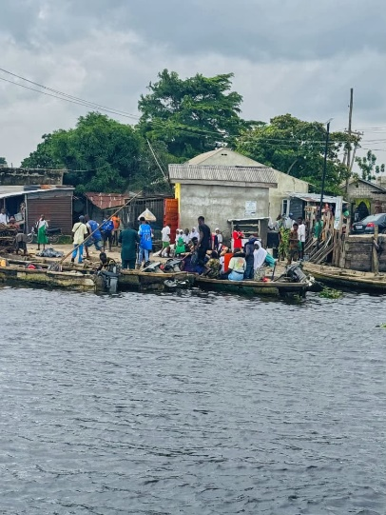
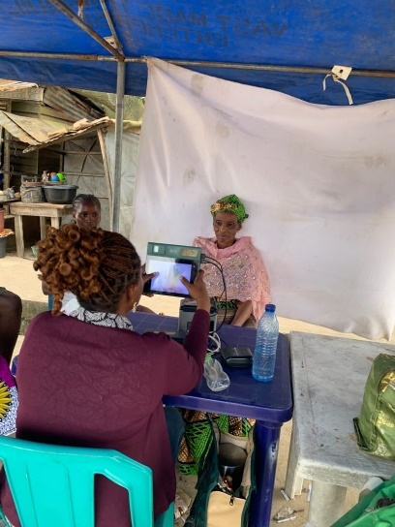
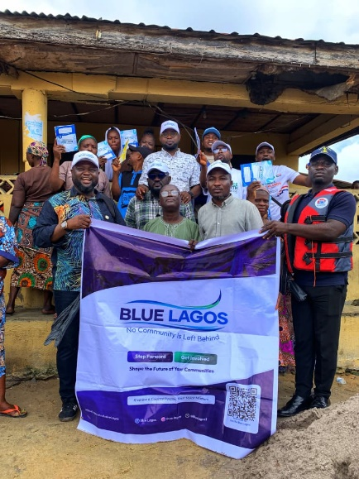
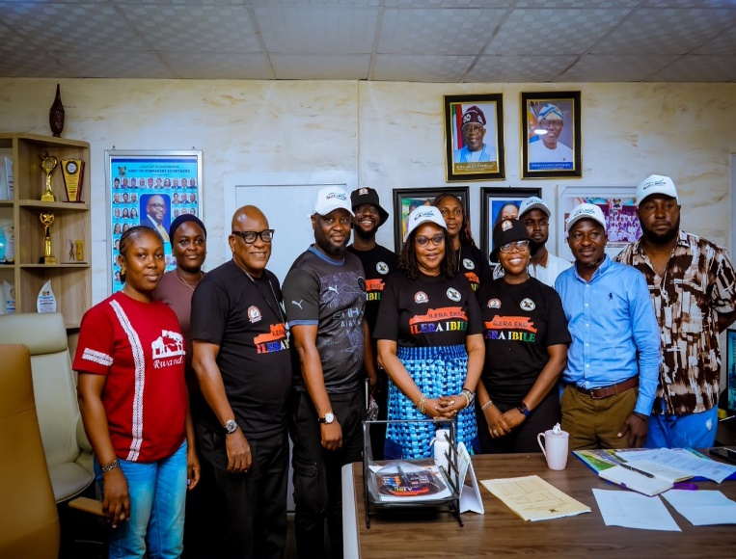
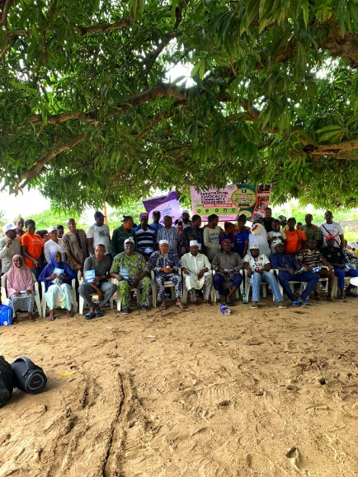
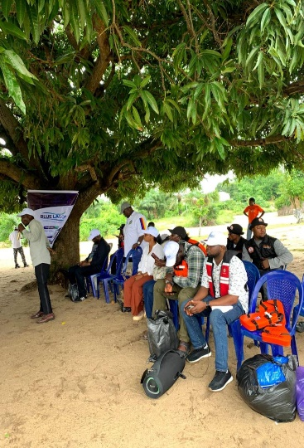
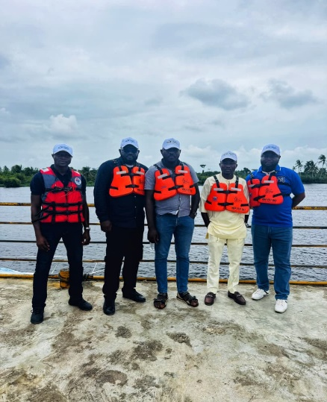

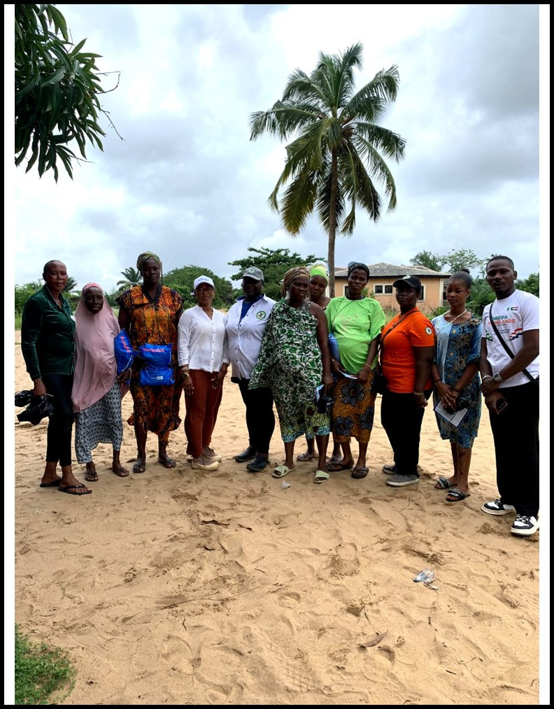 | 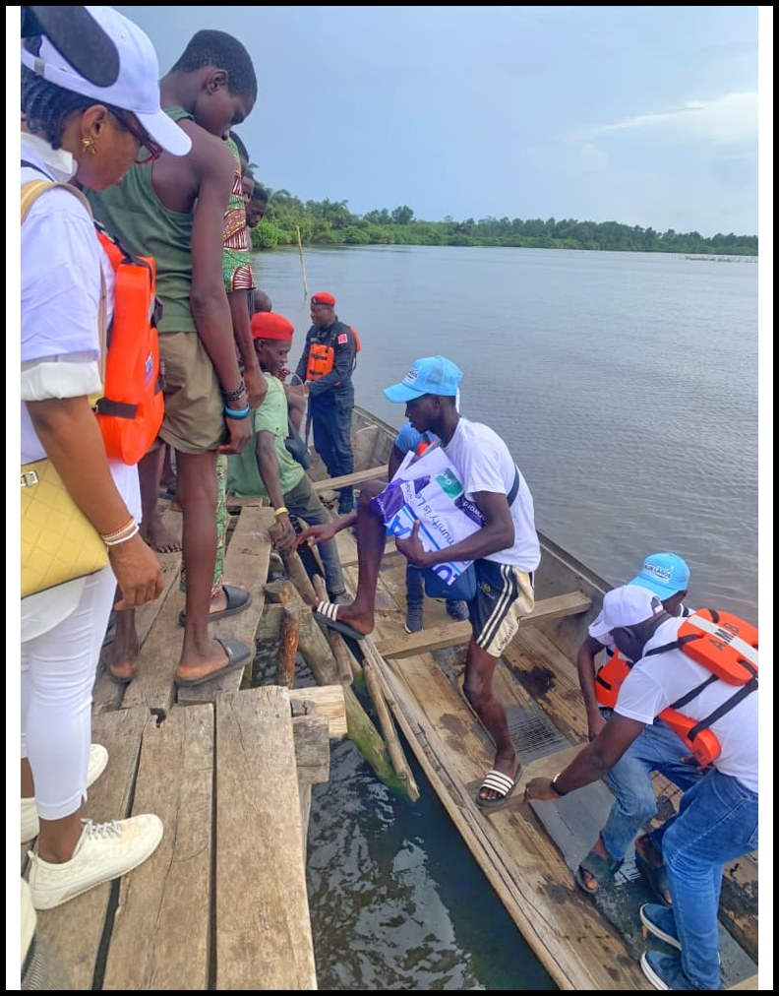 | 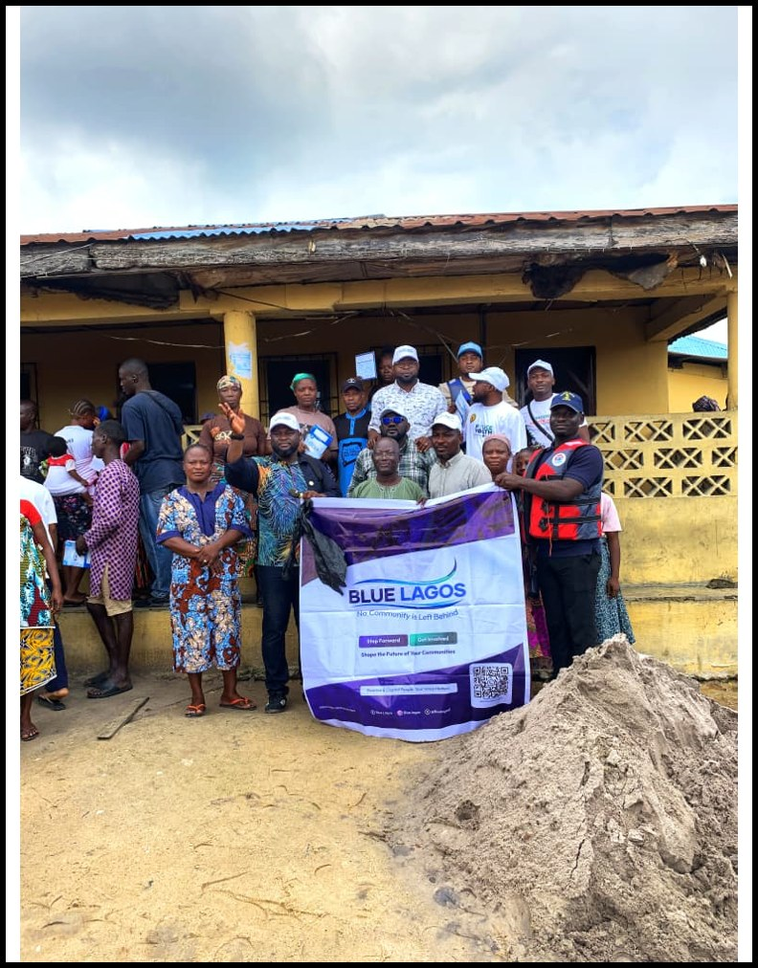 | 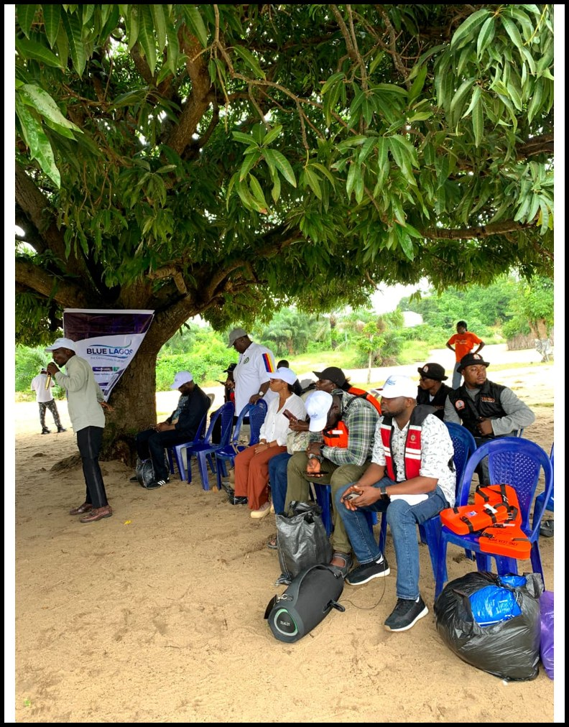
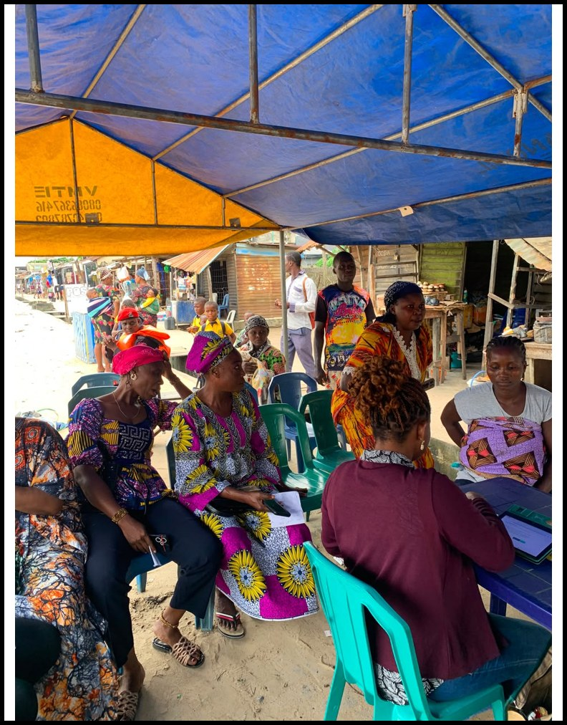 | 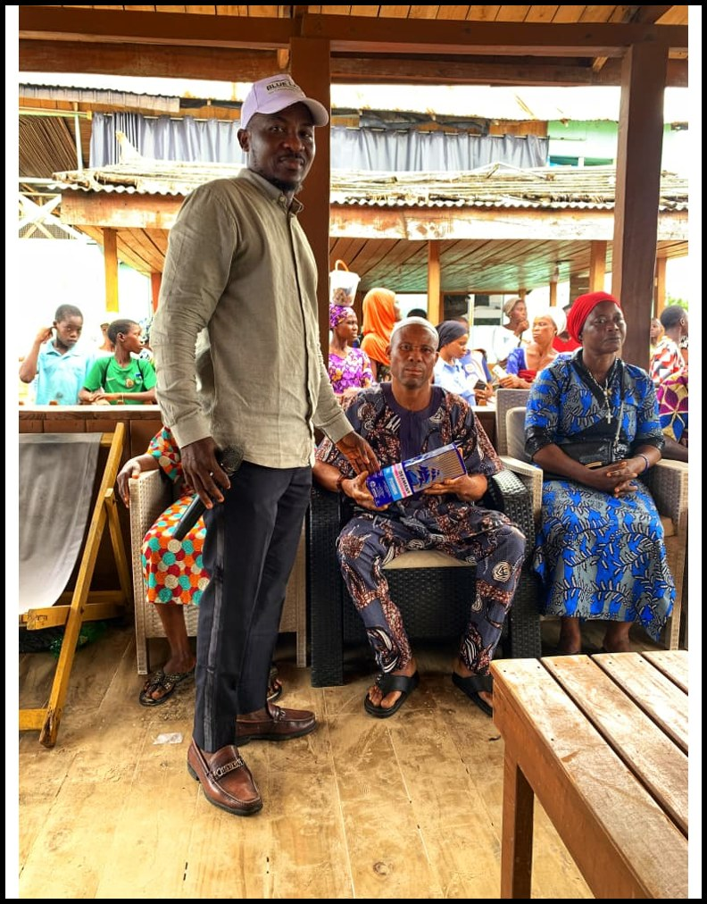 | 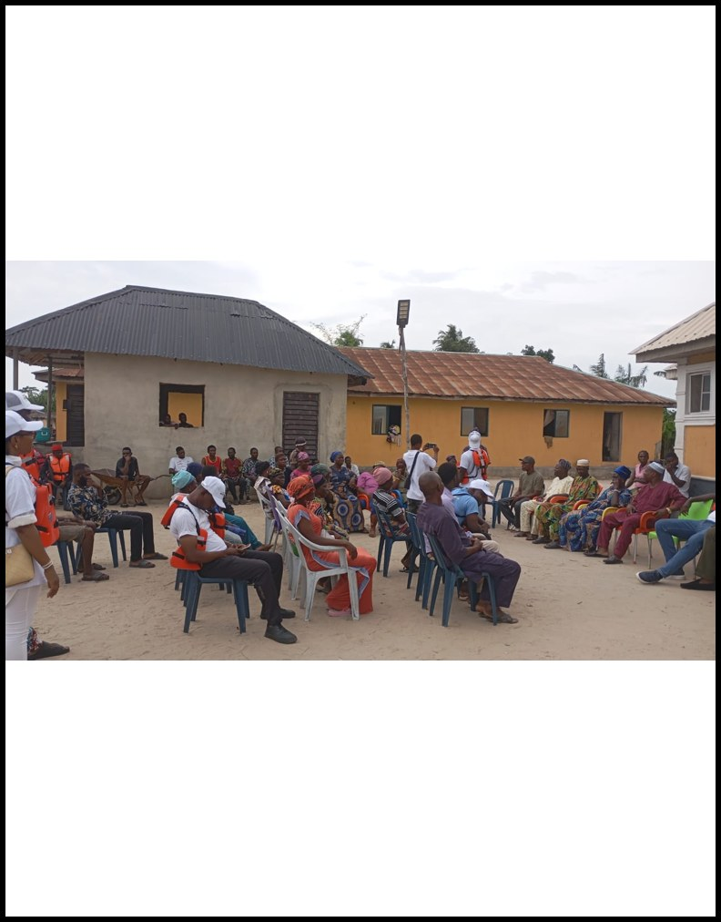 | 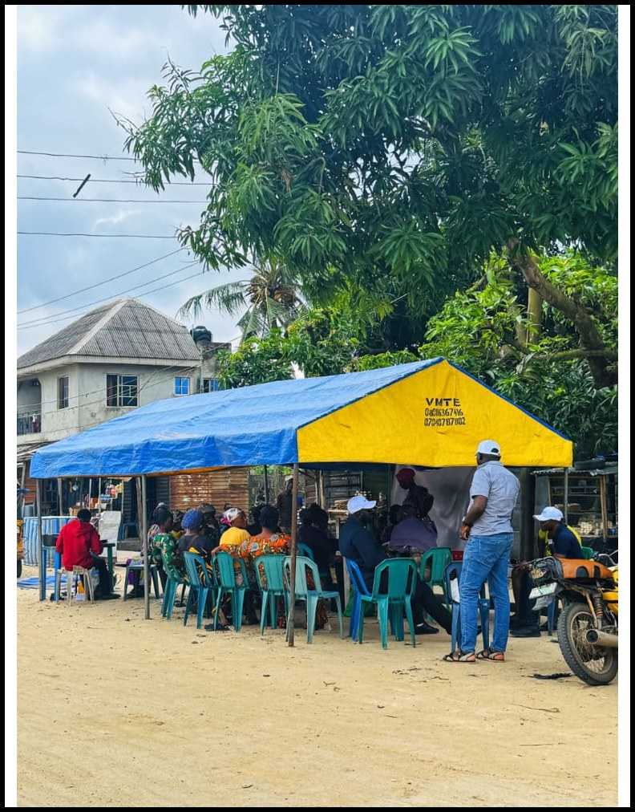
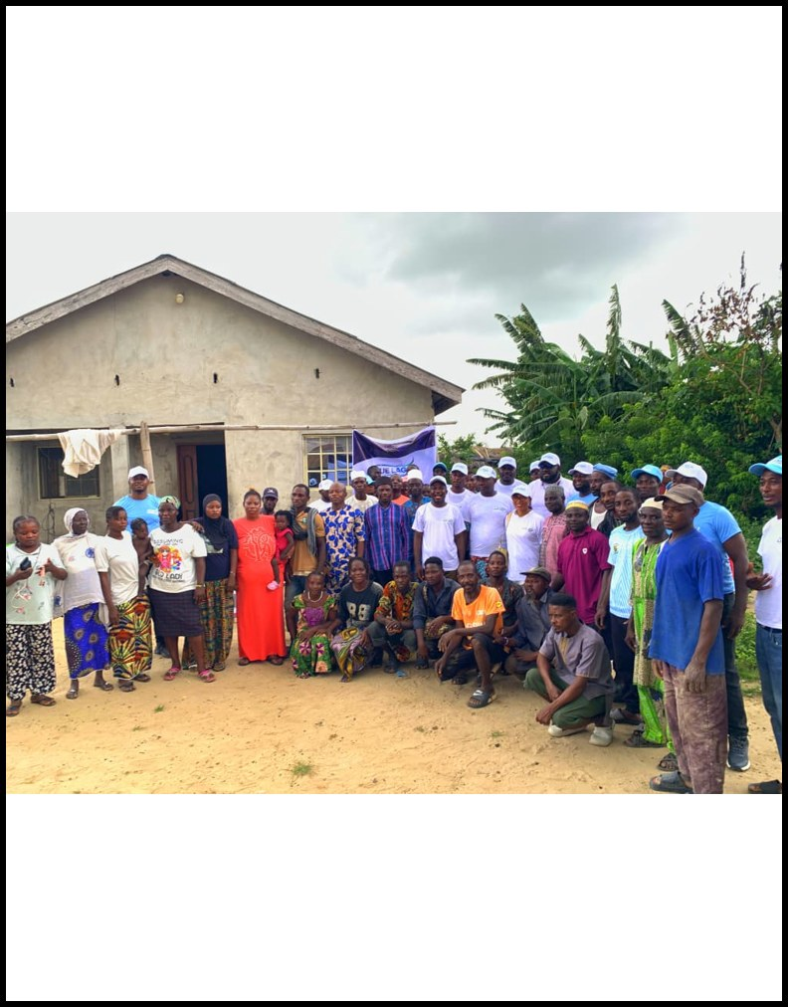 | 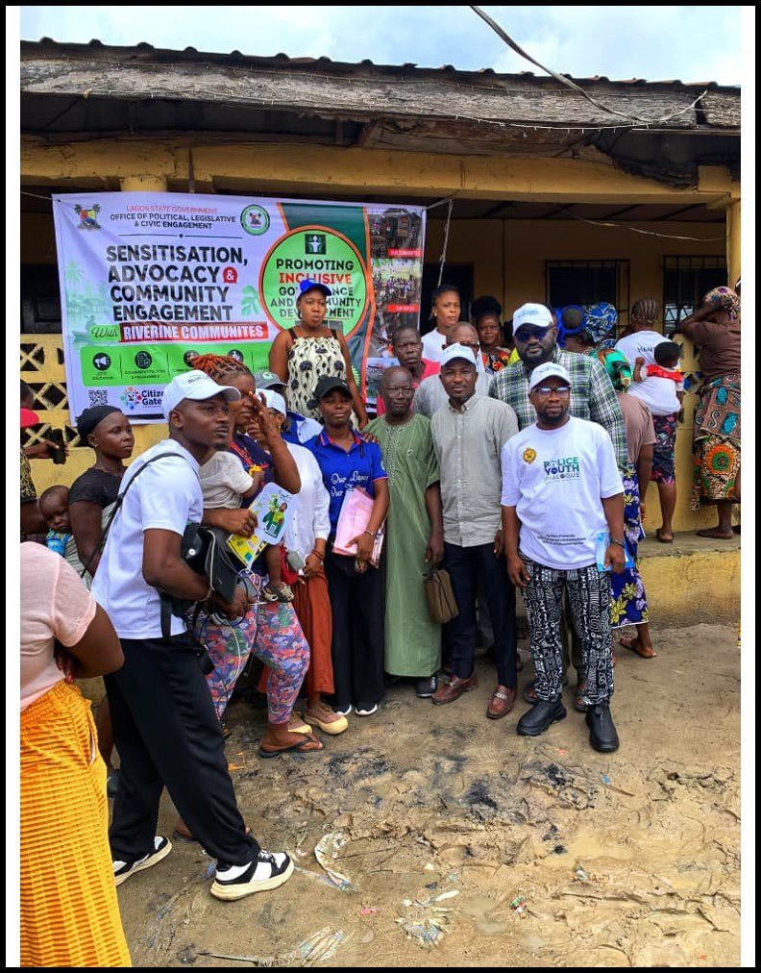 | 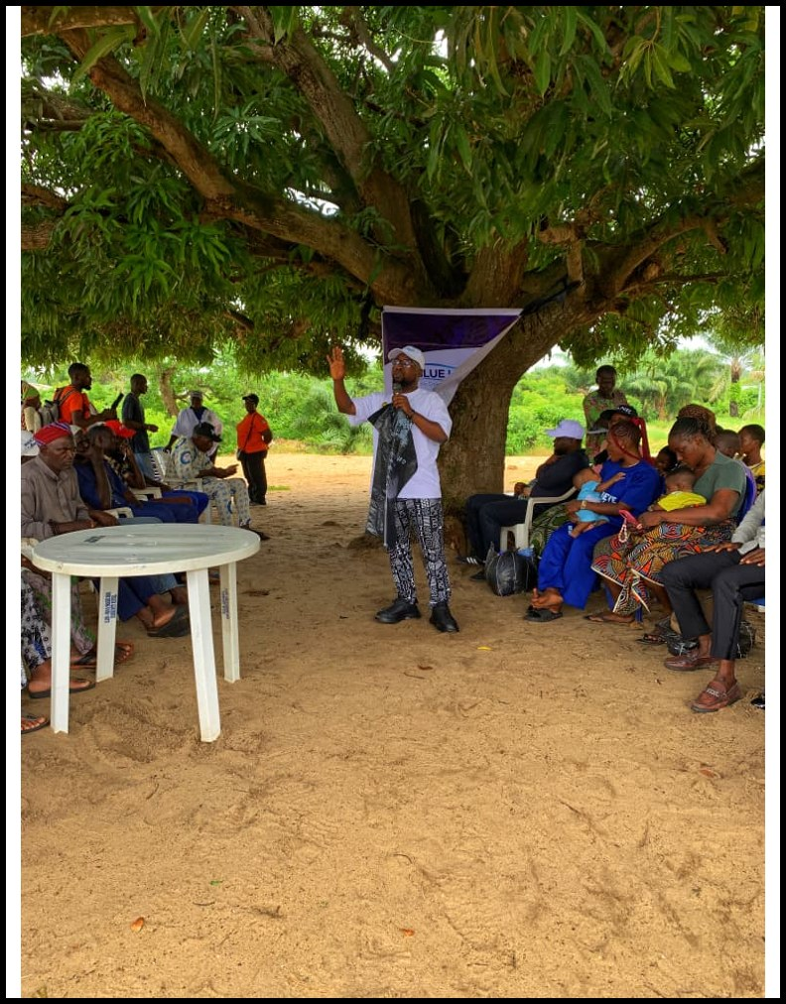 | 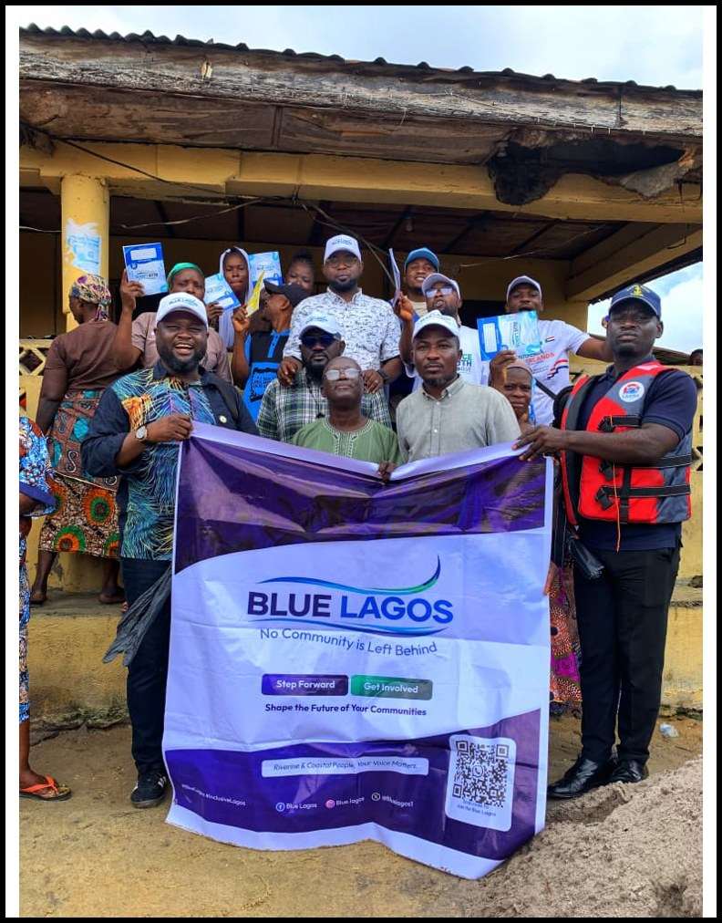
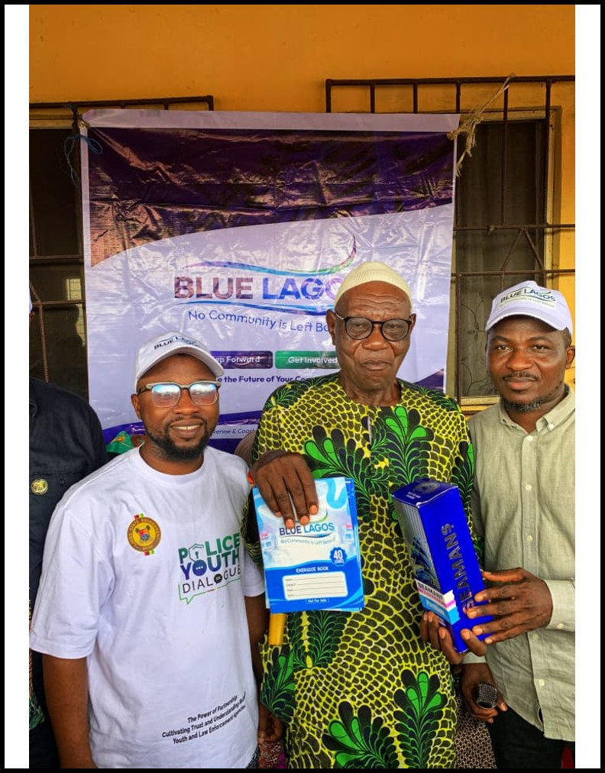 | 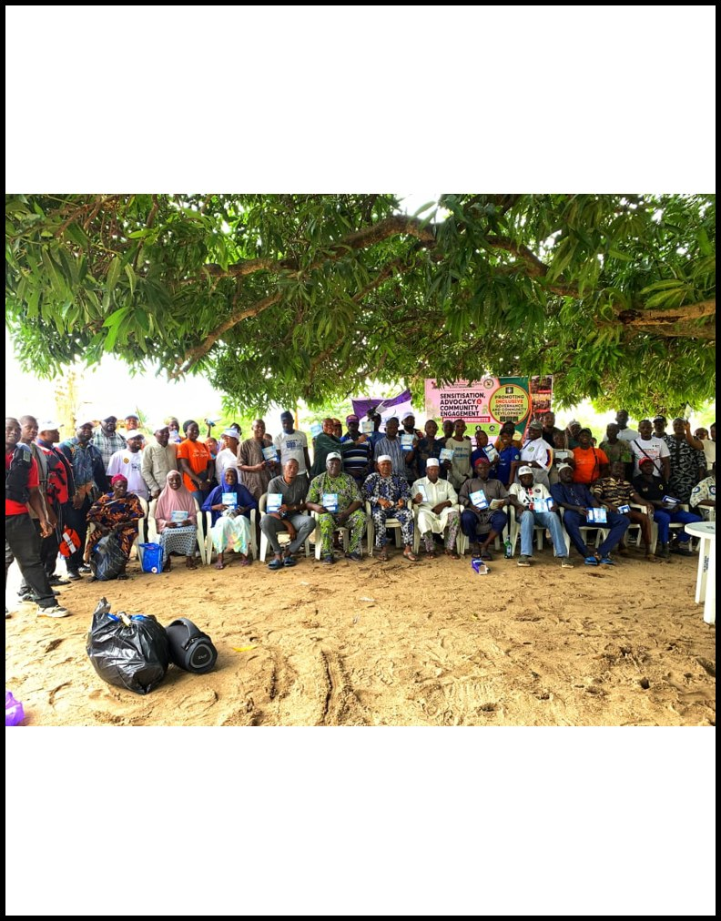 | 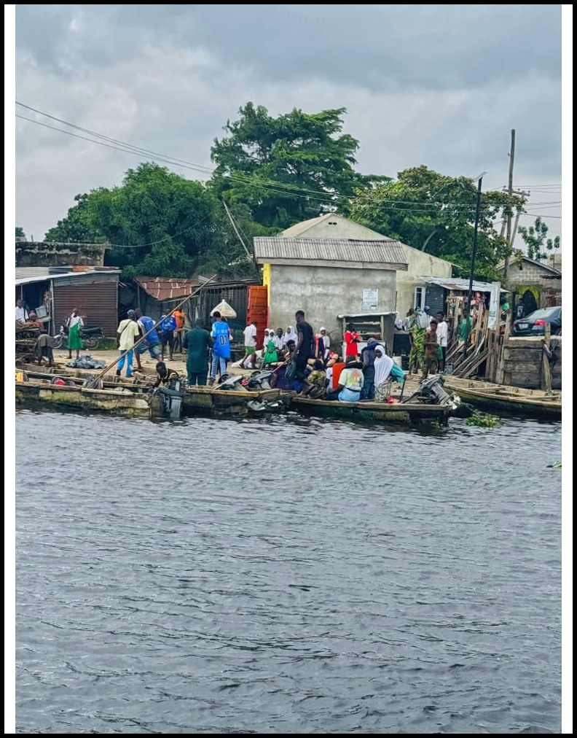 | 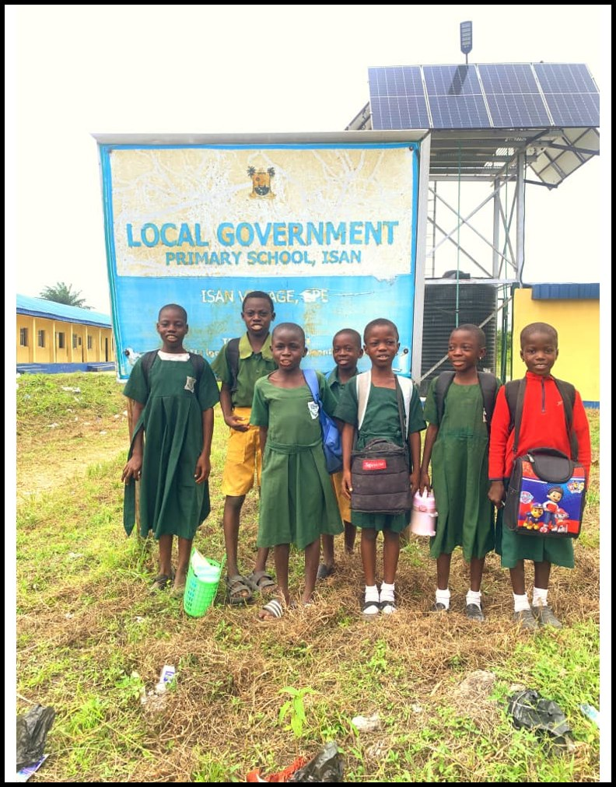
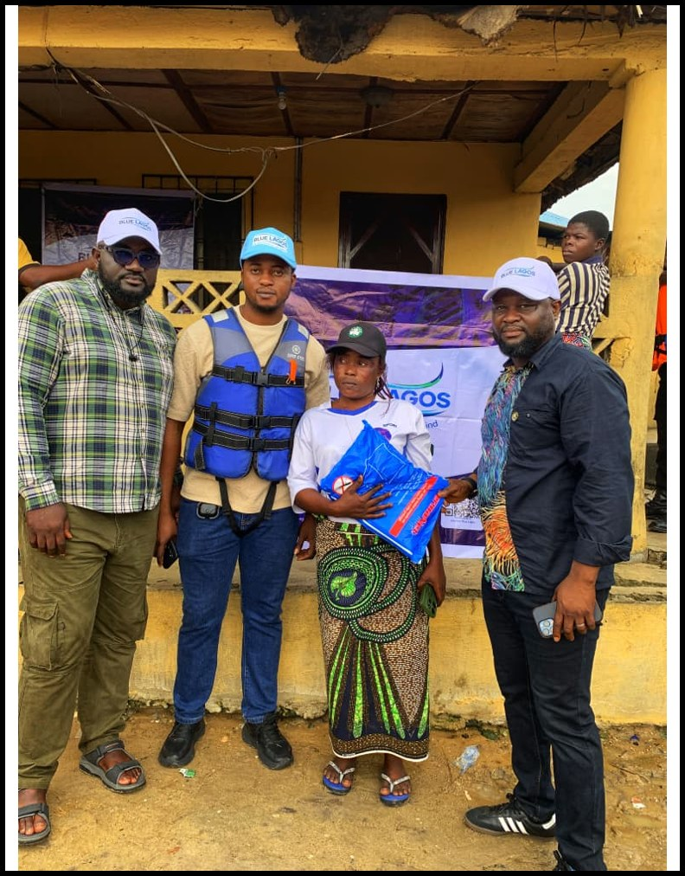 | 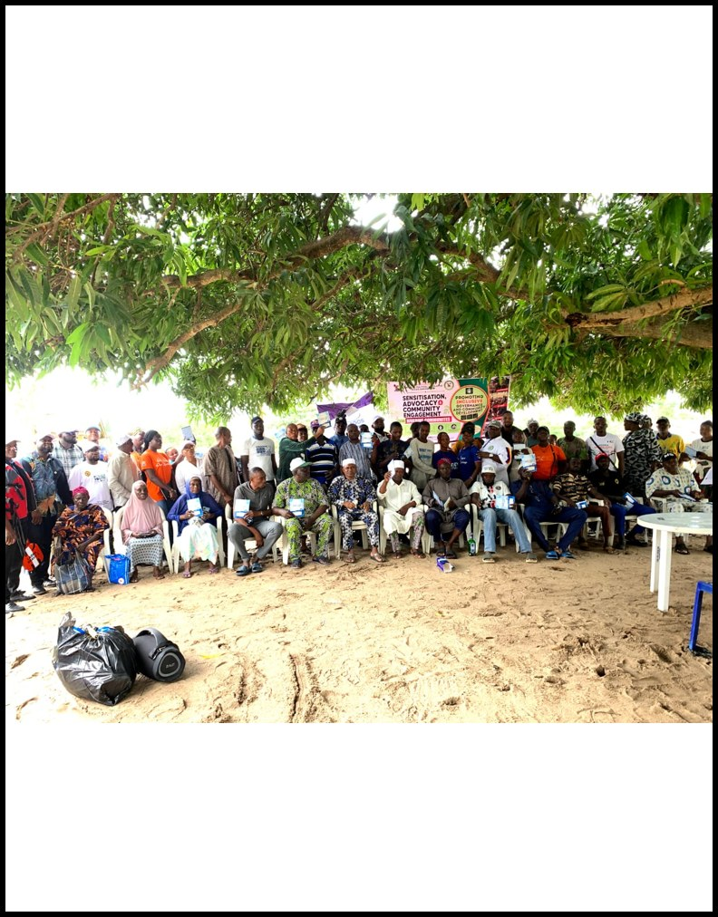 | 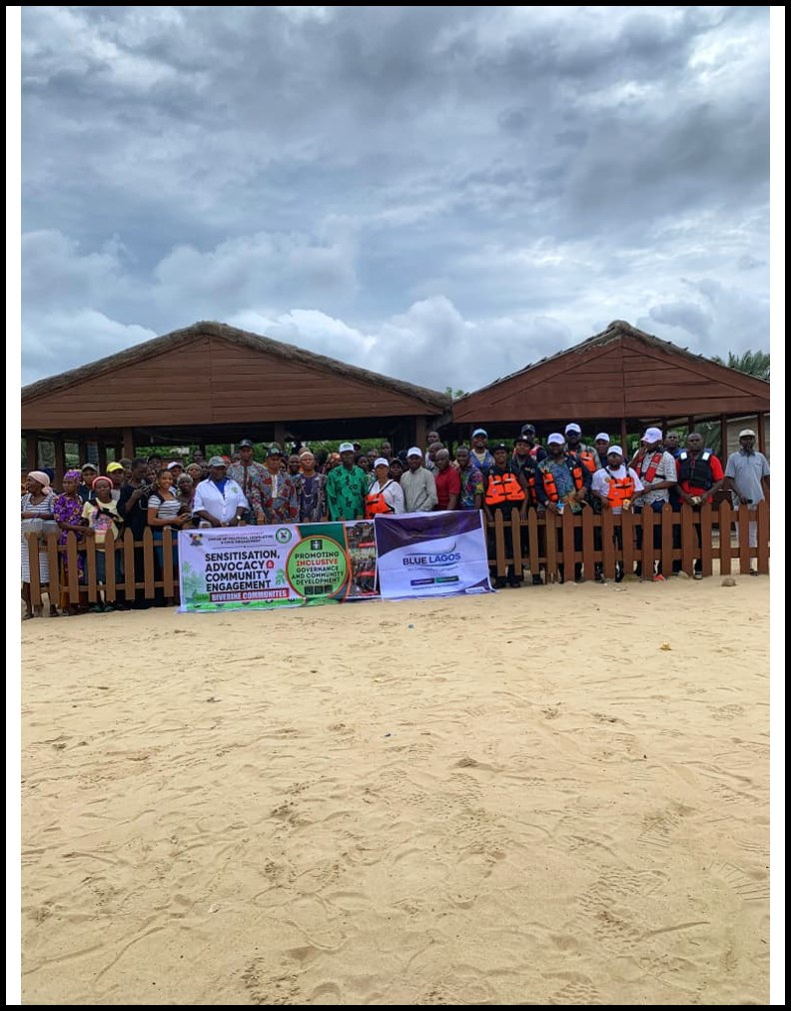 | 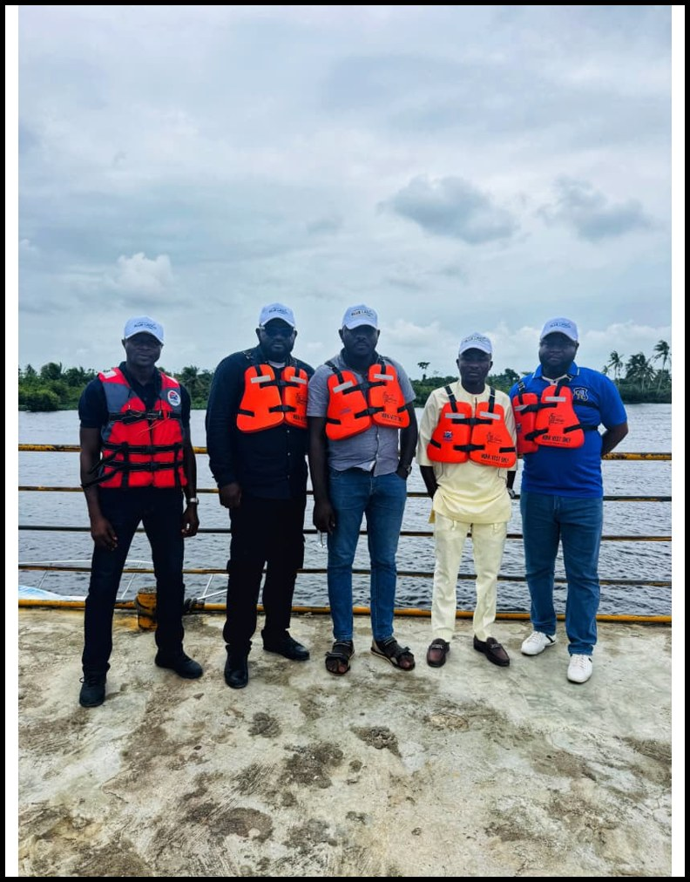
 |  | 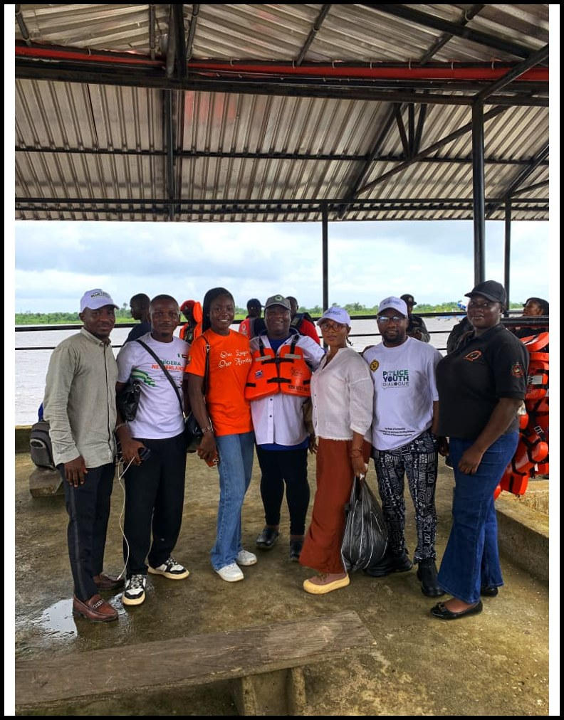 | 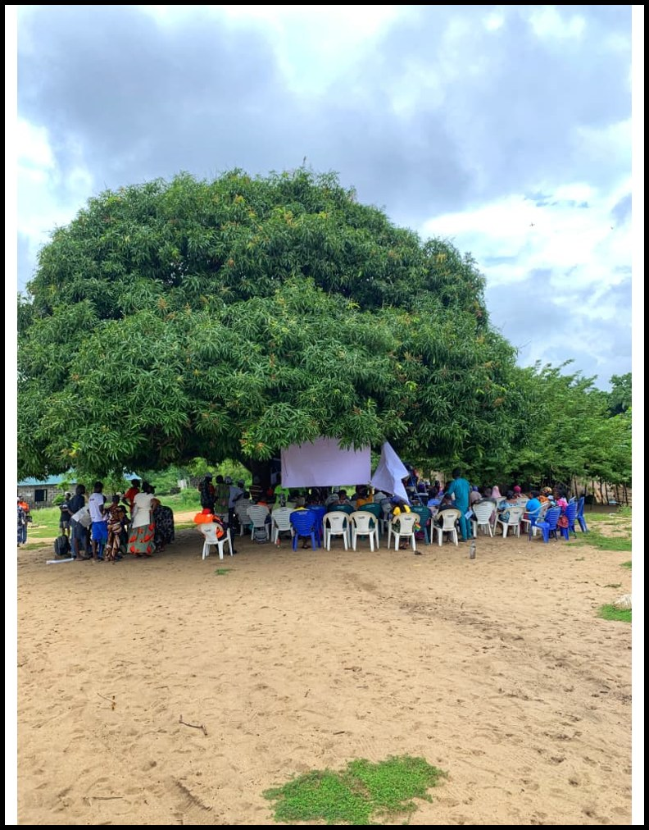


No Community is Left Behind
Instagram @blue.lagos | X @BlueLagos1 | YouTube Blue Lagos | www.bluelagos.org | bluelagos247@gmail.com

An interactive StoryMap version of this report is in development.

